**Swine Weight Estimation Using Various Image Processing Techniques**

by

**Kent Jude F. Castro/ ECE-4**

**Ma. Rhea Aubrey A. Roa/ ECE-4**

**Samantha Aeriel Y. Tanqueco/ ECE-4**

A Thesis Proposal Report Submitted to the School of Electrical Electronics and Computer Engineering

in Partial Fulfilment of the Requirements of the Degree

Bachelor of Science in Electronics Engineering

Mapúa University

January 2018

**Chapter 1**

**INTRODUCTION**

Weight is an important factor to consider when it comes to pig production. Having enough information regarding the pig’s weight can be very important due to various reasons. First, one will be able to know the health status of the animal, whether it is in a good condition or not. Second, being aware of the pig’s weight at a given time will help in determining the feeder requirements therefore reducing the feed cost which will eventually profit the commercial farms. Lastly, weight can be a key factor in determining the time that the animal will be sent to the market, since there are some circumstances wherein the buyer requires a certain weight before purchasing it. Primarily, there are two main approaches in determining a pig’s weight: direct and indirect. In the direct approach, the traditional weight measurement is used. Pigs are to be placed in a mechanical scale or electronic balance. This procedure is considered to be laborious for this would require at least two stockmen in order to measure the weight of a single pig and may cause injury occurring to the people working with the animal. But most importantly, this method will stress out the pigs that may lead to weight loss and worse, sudden death. On the contrary, indirect method includes visual weight estimation, image analysis as well as linear body measurement. Linear body measurement is considered to be the most typical tool in predicting the body weight in agricultural livestock because it uses some of the major measurements in weight estimation such as body length, height at withers, flank-flank and heart girth. In this study, we employed the indirect method through integrating the use of several image processing algorithms.

According to Yan Yang, there is a strong interrelationship between the weight of the pig and the volume composed by projected area and height. Based on different studies regarding the estimation of the weight of pigs, there are image processing algorithms that can be conducted to visually estimate a pig’s weight [1]. Image segmentation is one of image processing methods to extract data from an image or sequence of images. Active Contour, which is also known as deformable models or ‘snake’, is one type of segmentation method in the field of imaging [2]. Edge detection refers to the process of identifying as well as locating sharp discontinuities, which are abrupt changes in pixel intensity which characterize boundaries in a scene, in an image[3] and Canny Edge detector is said to be one of the most commonly used image processing tools[4]. Based on a similar study regarding weight estimation through image processing, feature extraction can also be used alongside segmentation in obtaining the pixels that is necessary for weight estimation. Feature extraction is a feature-taking process which describes the characteristic of the image. Feature resulted from feature extraction process is used to compare between one character to another character[2].

Measuring the weight of pig by direct method is difficult to do and it takes a lot of time. It is necessary to know the weight of the pig specifically in the meat market industry. Since pigs are being stressed out by direct measuring methods, this study seeks to examine which processing techniques will produce the smallest error in measuring the weight of the pig. There are certain weight ranges that will identify the classification of the swine. Thus, it was agreed upon for this study to include a feature wherein, the weight classification of the pig will be determined by comparing the estimated weight to the ideal weight with respect to its age. With this feature, it can be classified whether the pig is in the normal weight, underweight, or overweight range. A single camera or device will be used in the entire study where we will consider three sets of perspective: side view, top view, and a combination of both views by operating one perspective at a time. The canny edge detection algorithm will be utilized to separate the object of the study from the background. The Canny edge detector is an algorithm that includes Gaussian blur to clear any speckles and frees the image of noise.

The main objective of the study is to design and develop a device that will estimate the weight of a swine using the proposed image processing techniques which includes: Edge-based segmentation method, Localized Region-based Active Contours, filtering and feature extraction. The study is composed of the following specific objectives: (a) To be able to create a mathematical model for the weight of the swine with respect to its dimensions; (b) To extract the parameters needed in calculating the weight of the swine using OpenCV; (c) To classify the weight condition of the pig whether it is underweight, overweight, or normal.

Once this study is executed, it will benefit: Pig Farmers - one of the common problems that pig farmers are facing is the manual process of weighing pigs. This process is time-consuming and laborious. It usually takes at least 5 minutes for the pig farmers to weigh each pig manually. In addition to this, this manual procedure is stressful for both the pigs and the pig farmer. This study will help to provide a means of simplifying the weighing process. By determining the weight of the pig through image processing, the amount of time for manual labour required for weighing the pigs could greatly be reduced. This will benefit both the farmers and the pigs because it will lead to a stress-free way of measuring the weight of the pigs. This will help the farmers monitor their pigs more closely. Future researchers will be acquiring more ideas on how to provide solutions to the problems that the pig farmers are facing, widening the knowledge of future researchers on digital image processing techniques and other related topics which concerns the study. This would help researchers to find alternatives in measuring the weight of pigs using digital image analysis that is more cost-efficient and more accurate by applying their knowledge on Precision Agriculture from better future technology.

The study will be conducted in Mapúa University - Intramuros Campus where all the necessary hardware and software for accomplishing the study will be developed. This study is focused in the approximation of the weight of the pigs by taking a picture of it and analyzing it using the proposed image processing techniques. Acquired data will then be used for calculating the weight of the pigs by a microcontroller. An algorithm called canny edge detection will be used to separate the object of the study from the background. The measurement of the length of the body will start from its neck to its tail. Its chest circumference will be measured in relation to the location of the pig’s heart. The pig must be standing or restrained in a position where it is eating or sleeping for accurate results. A side-view and top view image of the pig will be used for the image processing in order to utilize the data from the pig’s body measurements and at the same time to acquire more accurate results. Pigs will be categorized according to their age with their corresponding weight. They will be categorized as either underweight, overweight or normal. All units of measurement will be in metric system since it is the most familiar type of measurement in majority of the population. Moreover, this study will not be considering all possible pathological conditions of the pigs that may cause and explain the inaccuracy of gathered results by the researchers as factors that will be affecting the weight of the pig. This study will not be considering pregnant pigs as part of the experiment and testing and calibration of the algorithm because of several parameters that may or may not affect the accuracy of the proposed algorithm Lastly, this study will only consider Landrace pigs in the testing and calibrating of the proposed device since it is the common breed in the piggery where the researchers will get the samples for the study and it is the most common breed here in the Philippines.

**Chapter 2**

**REVIEW OF RELATED LITERATURE**

In this part of the paper, recent studies about stress development of pigs due to various stimuli; specifically, when humans weigh pigs as well as causes and effects of these stressors and pigs will be discussed. This part will also tackle how technology helped pig farmers in their livelihood. Also found in this part are studies about different image processing techniques used for measurement of weight of pigs.

**Efficiency of Pig Farming Due to Technology**

Pig is one of the most important livestock in many states and it plays a major role in small time farmers. The traditional way of farmers limits the potential of this livestock. According to a study conducted by Kumbhakar and his colleagues, the conventional technology is more productive while organic farms are technically less efficient than conventional farms [5]. This is why adoption of farming technologies is important for efficiency in pig farming. A study conducted in India revealed that 81% of farmers adopted improved technology on breeding while 63% adopted health care practices at higher level in their farms. In this study, it showed that farming experience showed a positive and significant relationship with the adoption of improved technologies by farmers. As they are exposed to more advanced farming technology, frequent training should be done by the farmers [6].

**Causes and Effects of Stress on Pigs**

Stress is a process with multifactorial causes and produces an organic response that generates negative effects on animal health and production. One cause of stress on pigs is social stress. According to Andersen, social stress is greatly dependable on group sizes. These groups are kept in a closed space where the individuals are not able to withdraw from the group, and resources in the environment are most commonly limited and defensible. Larger groups seem to have less social stress compared to a smaller group. This reflects a lower probability of being able to utilize resources decreases as group sizes increases [7].

Another cause of stress is by improper handling. Stress can cause reduced weight gains[79,80], lower immune responses [81], alter physiological factors such as blood chemistry[82], and interfere with reproductive process [83,84]. In one study, young pigs were restrained alone in narrow boxes for two hours a day for three days. These animals subsequently showed reduced thymus weights, elevated serum cortisol levels, and reduced cell mediated immunity[81]. In a similar study pigs were shocked, placed in snout snares and slapped when they approach a handler. In another group, the pigs were petted when they approached the handler. The latter group gained more weight than the former group, and the former group showed increased blood levels in corticosteroids[79].

**Moving Pigs**

Pigs can be moved down a corridor by using a crowd panel, which is merely a panel of wood or metal with a handle built across the top. Some pigs can be stubborn and refuse to back up. In this case, a broom is gently brushed across the pig’s snout, this usually causes the pig to back up. When the pigs do not respond to the broom technique, the last resort would be to physically force the pig to back up. They can do this by placing shield over the pigs eyes. With its eyes shielded, even the most stubborn pig can usually back up without resorting to sheer force.[85]

**Table 2.1** Feeding Rate by Age and Expected Body Weight Gain [8]

|  |  |  |  |
| --- | --- | --- | --- |
| Age (in weeks) | Body Weight (kg) | Feed (kg/day) | Feed Type |
| 8-10 | 12-15 | 0.66 | Sow and weaner/starter |
| 10-12 | 15-20 | 1.0 | Sow and weaner/starter |
| 12-16 | 20-40 | 2.0 | Sow and weaner/starter |
| 16-18 | 40-50 | 2.5 | Finisher |
| 18-24 | 50-84 | 3.0 | Finisher |
| 24-28 | 84-105 | 3.5 | Finisher |

Table 2.1 shows the age of pigs in weeks, the range of the expected body weight in kilograms, kilogram of feed per day, and as well as the feed type. Pigs of ages in weeks 8-10 is expected to have a body weight that is around 12-15 kilograms. After 5-6 months, a single pig is expected to weigh around 84-105 kilograms. [8] When feeding animals, any sudden changes can lead to loss of production. Thus, feed changes should be as gradual as possible.

**Table 2.2** Growth Rate of Pigs and its Expected Weight Gain for a Specific Age [9]

|  |  |  |  |
| --- | --- | --- | --- |
| Age of pig (week) | Daily Liveweight Gain days | Weight (g/day) | Expected Weight (kg) |
| 4 | 28 | 215 | 7.00 |
| 6 | 42 | 395 | 12.5 |
| 8 | 56 | 630 | 21.3 |
| 10 | 70 | 660 | 30.5 |
| 12 | 84 | 715 | 40.5 |
| 14 | 98 | 800 | 51.5 |
| 16 | 112 | 965 | 65.0 |
| 18 | 126 | 1000 | 80.0 |
| 20 | 140 | 1100 | 95.0 |
| 22 | 154 | 1100 | 110.0 |

Table 2.2 shows the growth rate of pigs as well as its expected weight for that specific age. At 4 weeks, which is equivalent to a daily liveweight gain of 28 days, a single pig is expected to weigh at least 7 kilograms to be considered normal. At that span of 28 days, a pig can gain an average weight of 215 grams per day. After two months, which is equivalent to a daily liveweight gain days of 56, a single pig is now expected to gain an average weight of 630 grams per day and is expected to weight at least 21.3 kilograms. By the week 20-22 of a pig’s age, a single pig will now be expected to weigh at least 95.0-110.0 kilograms and gain a weight of utmost 1100 grams per day.

**Counterpart measures**

The most common reasons pigs are unwanted is because they grow bigger than expected, but it can be controlled through food intake [87]. Feeders give excessive amounts of treats and extras but do not realize the difficulties for the pigs to be overweight. While some are not feeding their pigs an appropriate amount of food. Some pig farmers encourage exercise by scattering the pig’s meals on the ground or inside of a treat dispenser that forces the pig to get up and move around to eat their food.

Feeds should meet the animal’s needs for maintenance, growth and reproduction [8]. A good pig feed contains sufficient energy, protein, minerals and vitamins. It is necessary for growth, body maintenance and the production of meat and milk in pigs. The nutritional needs of pigs can be divided into six categories or classes: Water, Carbohydrates, Fats, Proteins, Vitamins and Minerals.

**Table 2.3** Local Pig Feed/Ration: Mixing Ratio (Kg) [8]

|  |  |  |  |
| --- | --- | --- | --- |
| Ingredients | Pig weight (15 - 30 kg) | Pig weight (30 - 60 kg) | Pig weight (over 60 kg) |
| Soya Beans | 25 | 20 | 15 |
| Rice Bran | 25 | 30 | 35 |
| Maize | 20 | 25 | 30 |
| Broken Rice | 5 | 5 | 5 |
| Whean Bran | 20 | 15 | 10 |
| Leucaena Tree Leaves | 5 | 5 | 5 |
| Total (100 Kg) | 100 | 100 | 100 |
| Crude protein (%) | 16 | 15 | 14 |

The table above shows some of the feed ingredients of creep or formulation feeds. The daily feed requirements for piglets should be by giving creep pellets (0.5 - 1.00 kg/day) from day 7 up to weaning time (21 days) per piglet, and feed should be mixed with sow and weaner meal

the last one week before weaning. For Growing or finishing pigs, pigs weaned at 3 - 5 weeks of 11 – 13 kg body weight should continue being fed on the starter diet until they reach 18 kg live weight. Pigs weaned at 7 weeks or older may be switched gradually to sow and weaner diet and all ration changes should be made gradually. If not possible, the feeding level of the new diet should be low until the pigs become accustomed to it.

**Table 2.4** Summary of the Methods Used in Related Studies of Weight Estimation

|  |  |  |  |
| --- | --- | --- | --- |
| Object of the study | Method | Accuracy & Error | Reference |
| Eggs | * Canny Edge Detection * Back Propagation Method * Combination of Back Propagation and Least Squares Type Method | * Accuracy = 97.67%   Error = 2.33%   * MSE = 0.2955   MAE = 0.3285  SSE = 35.46.49 | * [10] * [11] |
| Beef Cattles | * Localized Region Based Active Contour * Linear Regression | * Accuracy = 73.21362%   Error = 26.78638% | * [2] |
| Pigs | * Fixed Threshold Method * Median Filter * Image Opening (Erosion and Dilation) * 2D image * Skeletonization * Manual Measurements (calipers and measuring tape) * Curve Fitting * Ellipse Fitting Algorithm * Image Segmentation * Object Detection and Selection Method * Threshold the Depth * Depth Image * Microsoft Kinect Prototype imaging system * Image Analysis * Grey level Threshold Method * Edge Detection routine * Regression analysis * Facial Geometry * Image Trigger Method | * Accuracy = Error = 5% * Error = 3.2% * Accuracy =   Error = 8-9%   * Accuracy = 97.5% * Error = 2.95%   Error = 2.06%   * Accuracy = 83%   Error = 5%   * Error = 2.358% * Error = 2.8% | * [12] * [1] * [13] * [14] * [15] * [16] * [17] * [18] |
| Holstein Cows | * Regression analysis * Photogrammetry * Digital Image Analysis | * Accuracy = 98.13%   Error = 1.87% | * [19] |
| Flatfish | * Structure light and image analysis | * Error = 5% | * [20] |

Table 2.4 shows a summary of methods and algorithms used in related studies as well as the corresponding object of their study.

A study conducted by Pradana et al. wherein they determined the weight of a cattle using Active Contour and Linear Regression suggests that a side view picture and chest circumference feature was appropriate in calculating the weight of the cattle [2]. Using the side view image of the cattle, it will be segmented by the types of meat as shown in the figure below.

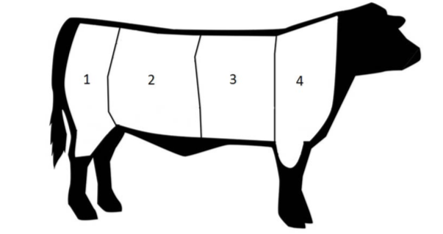

**Figure 2.1** Segmented Feature Extraction of side picture [2]

They used Linear regression wherein it attempts to model the relationship between two variables by fitting a linear equation to the acquired data. This method is used to calculate the weight of beef cattle based on the number of pixels of each segment and also elliptical circumference. The pixel count in every part of the segmented side view image used to calculate the weight of the cattle shown in the table below.

**Table 2.5** Pixel Count in Each Part of the Segmented Side View Image of the Cattle [2]

|  |  |  |  |  |  |
| --- | --- | --- | --- | --- | --- |
|  | Part 1  Coefficient | Part 2  Coefficient | Part 3  Coefficient | Part 4  Coefficient | Without  Segmentation  Coefficient |
| Intercept | 1.53E+01 | 1.53E+01 | 9.52E+00 | 8.96E+00 | 4.91E+01 |
| X Variable 1 | 1.30E-06 | 6.34E-07 | 4.68E-07 | 5.46E-07 | 6.76E-07 |
| X Variable 2 | 1.04E-01 | 1.05E-01 | 6.50E-02 | 6.11E-02 | 3.35E-01 |

The weight of each segmented will be calculated with the use of linear regression. The accuracy of the system was computed to be 73.21362% for all parts as well as without segmentation using the equation: Accuracy = 1-%error. The results of the performance of the system is shown in the table below where each part has the same accuracy and error. This is because the anatomical shape of small and big animals have the same characteristics.

**Table 2.6** System Accuracy for Each Part of the Segmented Side View Image of the Cattle [2]

|  |  |  |
| --- | --- | --- |
|  | Error | Accuracy |
| Part 1 | 26.78638 | 73.21362 |
| Part 2 | 26.78638 | 73.21362 |
| Part 3 | 26.78638 | 73.21362 |
| Part 4 | 26.78638 | 73.21362 |
| Without Segmentation | 26.78638 | 73.21362 |

Another approach in weight estimation is by using statistical model. A study was conducted by Kollis et al. wherein a system for data collection and image processing was designed to function in an automated fashion. In order to detect the pig, a fixed threshold method was used. This threshold was determined by an offline calibration step. The fixed threshold method was used due to its simplicity. The figure below illustrates the process of segmentation based on a fixed threshold.

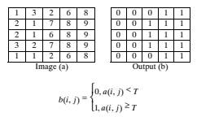

**Figure 2.2** Segmentation based on a fixed threshold. [12]

The figure above displays the process of segmentation based on a fixed threshold. The elements of the input image represent pixel intensities. The output b is a binary image. The binary 1 in output (b) represents the outline of the detected pig. This means that the outline of the detected pig will be colored in white while the background, which is represented by binary 0 will be colored in black.

A study [13] was conducted by Brandl and Jorgensen in the year 1996. In this study, three methods for measuring the pig dimensions were used: calipers and measuring tape; a livestock scaling instrument; and measurement obtained from photographs. The first method had the highest accuracy. Klatt and Glende (1975) found that the weight of the pig could be described as a quadratic function of body measurements [21]. Petherick (1983) found that the area that a pig occupies and space allowance, depends on its live weight. The function $A_{PIG}=K*W^{0.66}$ was used, where K is a constant and W is live weight [22].

**Table 2.7** Description of measurements and their corresponding abbreviation [13]

|  |  |  |
| --- | --- | --- |
| Abbreviation | Name |  |
| TS | Tail to scapula | Ma/Vb |
| SS | Snout to shoulder | Ma/Vb |
| BB | Breadth at back | Ma/Vb |
| BM | Breadth at middle | Ma/Vb |
| SW | Shoulder width | Ma/Vb |
| HB | Height at back | Ma |
| HS | Height at shoulder | Ma |
| AA | Body area | Vb |

aM = Manual

bV = Video

In table 2.7 are the measurements recorded and their respective abbreviations. The pigs were concurrently recorded on video tape using the set-up shown in figure 2.3.

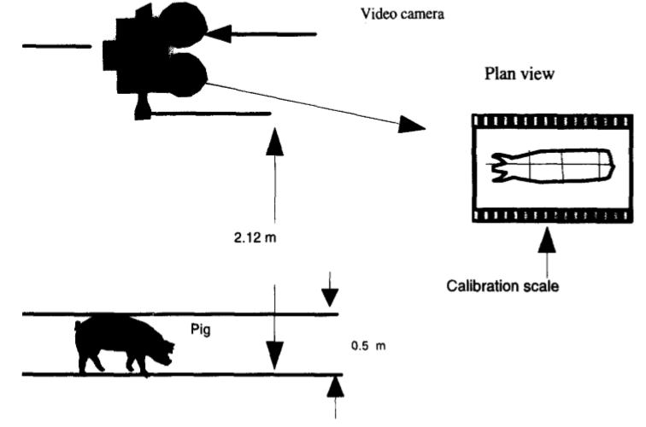

**Figure 2.3** The position of the camera in the stable [13]

The video camera was situated vertically above the animals, 2.12 m above ground. The video recordings took place outside the pens immediately after the conventional weighing. From each weighing, five frames from the video recording were selected at random. Only frames in which the whole pig could be seen were selected. The video frames were analyzed using a semiautomatic system [23].

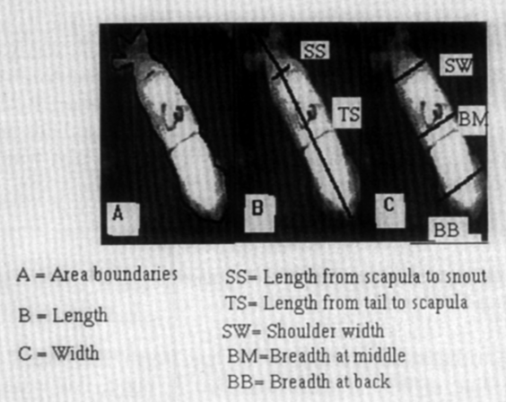

**Figure.2.4** Measurement Points [13]

The software was menu-driven and it allowed scanning of the video tape and freezing of individual frames on the screen. Using a mouse, eight points on the outline of the pig were selected as shown in Figure 2.4. These points are used as end points in different measures of length and width.

Exploratory data analysis showed that the relationship between area of the pig and its weight was not a simple linear or quadratic function. Also, the variance in weight increased almost proportionally with increasing weight. It was thus decided to employ a common curve fitting procedure [24] which describes the relationship between area and weight, and to use the residuals from the mean curve to investigate the influence of the other factors in the experiment. The spline functions were fitted on the experiment as a whole, and for each replicate individually. Eventually, the residuals from the mean curve were analyzed with respect to the effect of feeding methods and breed. The spline functions were based on a method described by Wold (1974), but it had no ability to separate the random effect of pigs within blocks from the residuals [24]. Therefore, the following mixed model was used [25] which analyzes the fixed effects such as effect of breed, feeding methods and growth periods, and the random effects such as effect of blocks and pigs within blocks through the growth periods.

$Y_{ijklm}= μ+α_{i}+β_{j}+γ_{k}+b*δ_{ijklm}+b**δ_{ijklm}^{2}+b***δ_{ijklm}^{3}+δ_{ijklm}\left(α_{i}+β_{j}+γ_{k}\right)+B_{b}+P_{ijkl}\left(B_{b}\right)+ϵ_{ijklm}$ (2.2)

Model 1 (mixed model) was conducted for each replicate, similarly to the spline functions model. For simplicity, the effect of interaction between squared and cubic body area and fixed effects was not written in the model, but has been tested [13].

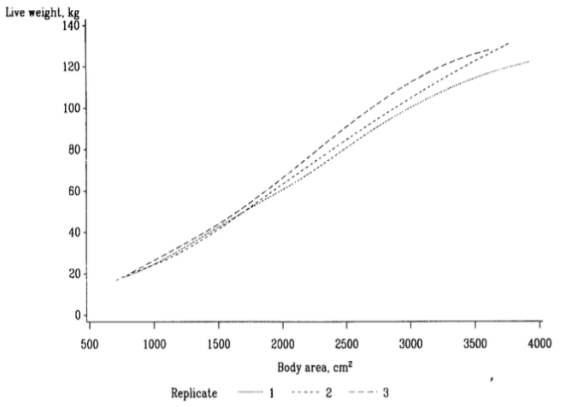

**Figure 2.5** The estimation of live weight using spline functions for each replicate [13]

As seen in the figure above, the live weight corresponding to a given area increased with each replication of the experiment.

**Table 2.8** Random effect on weight estimation from body area [13]

|  |  |  |  |  |  |
| --- | --- | --- | --- | --- | --- |
| Replicate | Block Variance $σ_{b}^{2}$ | Pig (Block) Variance $$σ_{p(b)}^{2}$$ | Intraclass Correlation ${σ_{b}^{2}}/{\left(σ_{b}^{2}+σ_{e}^{2}\right)}$ & $${σ_{p(b)}^{2}}/{\left(σ_{p(b)}^{2}+σ_{e}^{2}\right)}$$ | Residual Variance $$σ_{e}^{2}$$ | Accuracy $\exp\left[\left(ln\left(100\right)+σ_{e}\right)\right]$ |
| 1 | 0.0023 | 0.0048 | 0.4182  0.6000 | 0.0032  0.0079a | ±5.8%  ±9.3%a |
| 2 | 0.0015 | 0.0021 | 0.3488  0.4286 | 0.0028  0.0061a | ±5.4%  ±8.2%a |
| 3 | 0.0005 | 0.0009 | 0.1724  0.2727 | 0.0024  0.0061a | ±5.0%  ±8.2%a |

a Results from spline functions, otherwise from the mixed model.

Table 2.8 shows the accuracy percentage, which demonstrates the difference in accuracy of weight estimation between the model of spline functions and the mixed model.

Table 2.8 also shows a summary of the methods used in estimating weight of pigs from 2D images. A study that was conducted by Yan Yang et al., states that an image processing algorithm, specifically image segmentation, was used to estimate the weight of a swine. The first method is construction of difference image. Difference image is constructed from the RGB channels, which suppresses the background and emphasizes the foreground objects and can be denoted through $\left(x,y\right)= \frac{g\left(x,y\right)+b\left(x,y\right)-r\left(x,y\right)}{{\left[g\left(x,y\right)+b\left(x,y\right)+r\left(x,y\right)\right]}^{1.5}}$. Another is the automatic selection of threshold. In figure 2.6 (b), shows a histogram wherein the pixels if the pig is concentrated on a region of the first peak and the background is concentrated on the right part. An additional algorithm of image segmentation that is mentioned is the binarization and after-processing. A binary connected component is utilized to extract a single-connectivity region. The pictures in (c) and (d) shows an example of an after processing results in both side and top view.

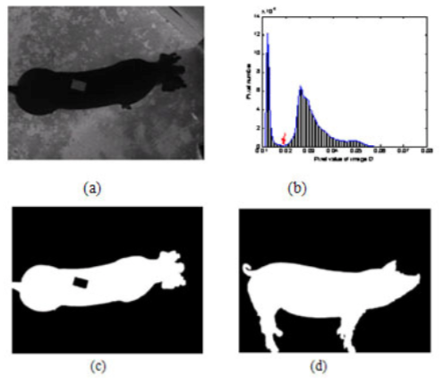

**Figure 2.6** Estimating pig weight from 2D images: a) difference image where the pig region is salient b) typical histogram c) and d) example of after-processing results[1]

Reference [11] in Table 2.4 shows the methods utilized in measuring the weight of an egg. The width and length of the egg was measured by real time image processing. According to Payam Javadikia et al., There are three steps in detecting the size of the egg: first is through converting the dimensions of the image to a square matrix by a MATLAB software. The color image in RGB space was transformed to HSV space. Next, segmentation was done by making the pixels black on the outer side of the egg. The pixels in the eggshell image was counted to obtain its area. There is no need for calibration because the distance of the camera from the egg does not vary. Finally, detecting the exterior shape of the egg to specify the area of the eggshell in the image approximately. To be able to detect the size of the diameter of the egg, canny method of edge detector with edge function was used along with the image wherein the number of pixels was counted. Figure 2.7 [11] shows the result of using the edge function with 0.7 thresholds. The big and small diameters of the egg are also visible in the picture.

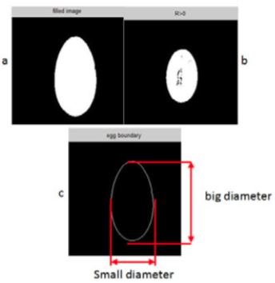

**Figure 2.7** Measuring the Weight of Egg with Image Processing and ANFIS Model. [11] a.) red color surface b.) the picture filled by the imfill function c.) identify the edge of the egg

The rows and columns with non-zero values (the border edge of the egg) were arranged in descending order in the original matrix depending on their position in the matrix of the resulting image. The minimum and the maximum values of the resulting matrix (in both x and y directions) denote the four points shown in Figure 2.7. Lastly, through the subtraction of minimum and maximum values from each other in both x and y directions, the big and small diameters of the egg were obtained.

A study was conducted by Kashiha et al. wherein two experiments identical in setup were implemented last February and June 2011, whereby data from the former were used to develop a model while the latter was a validation experiment. Forty gender-balanced pigs, were selected and 10 pigs were assigned to each of four fully slatted pens after weaning. Top-view video images of the pigs in the four pens were captured by cameras installed in the rafters of the barn. Video images from top view were collected with Panasonic WV-BP330 cameras for all pens during 13 days for 12 hours a day resulting in 156 hours of video recording per experiment.

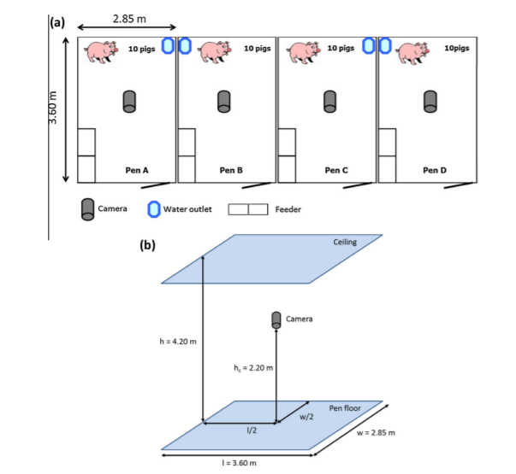

**Figure 2.8** Setup of the Study [26]

Pig body weight was also measured twice a week using MS Schippers MS-100 weighing scale. These measurements served as the gold standard reference to which the estimated weights obtained from image analysis and modelling were compared. The captured video images were subsequently processed offline in the MATLAB 2010A environment to extract the outline of the body area, which consisted of a two-step process. First, pigs were localized and segmented in the image using an ellipse fitting algorithm. Second, head and neck in the image were separated from the body to maximize correlation to BW [16]. To localize pigs within the pen, an ellipse fitting algorithm using Generalised Hough Transform as introduced by Davies (1989) was adapted. In the next step, the corpus image was separated from the head by using the same ellipse fitting algorithm.

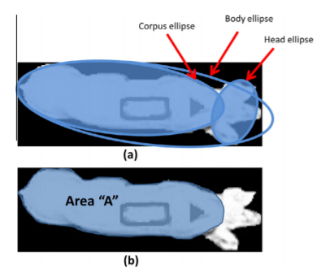

**Figure 2.9** Ellipse fitting and corpus and head separation [26]

Figure 2.9 (a) is where the extracted body using ellipse fitting and repeating of the ellipse fitting to remove the head and the corpus from the body. This resulted to the body area “A” which will be used for BW estimation.

Here, the algorithm gave two ellipses. The larger ellipse represents the corpus and the smaller one the head. The corpus area of the pig surrounded by the corpus ellipse, namely ‘‘A’’ was calculated once a minute and used for BW estimation. To limit processing to standard standing positions of pigs in weight estimation, 2700 area pixels (for camera height of 2.2 m) were regarded as a minimum of ‘‘A’’. Since the aim was to estimate individual pig weight as well as at group level, pigs needed to be marked for identification. For this purpose, a specific pattern was stamped on the back of each pig using blue dye (MS Long spray, Belgian MS Schippers).

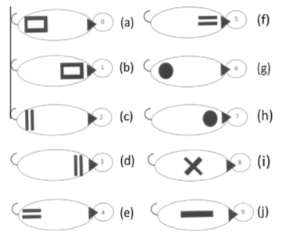

**Figure 2.10** Variety of patterns applied for identification purposes [26]

Figure 2.10 shows the identification patterns used to identify 10 individual pigs. For further description regarding the identification by using pattern analysis the reader is referred to [26].

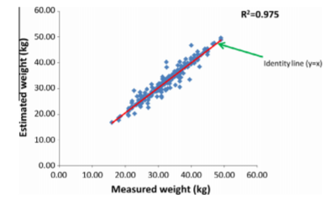

**Figure 2.11** Measured weights versus estimated weights over six measurement days of all four pens with ten pigs per pen (240 data points) in the validation experiment [26]

Figure 2.11 shows the measured actual weights versus the estimated weights over six days of measurements for all four pens and ten pigs per pen (240 data points). The ideal case was that all of the data points align with the identity line (R2 of 100% which means for every data point, estimated weight would equal the measured weight). This means the more erratic the points are, the lower R2 and accuracy of weight estimation will be. Overall R2 is 0.975 with standard error of 0.0182. In total, using TF modelling of top-view pig body area, pigs weight could be estimated with an accuracy of 97.5% and 96.2% at group2 and individual level, respectively.

**Table 2.9** Comparison of results of applying “Linear regression”. “Mixed effects (non-linear)” and TF models to body area data in group level [26]

|  |  |  |  |  |
| --- | --- | --- | --- | --- |
| Model | Data Points | R2 | SEa (%) | SE (kg) |
| Linear regression | 240 | 0.871 | 10.04 | 4.52 |
| Mixed effects (non-linear) | 240 | 0.943 | 5.95 | 2.68 |
| TF | 240 | 0.975 | 1.82 | 0.82 |

a Standard error.

Previous work on this topic, namely linear regression models [27] and mixed effects (non-linear) models [28]. Table 2.9 compares the results of these three methods applied to the group level data of the validation experiment while data of the first experiment were used to develop the models. The data presented in Table 2.9 indicates that the TF model yields a higher R2 and a lower SE, which means this method can estimate BW with a higher accuracy and reliability. In addition, the proposed method is capable of estimating BW for individual pigs with an accuracy of 96.2% (SE = 1.23 kg) while the competing methods do not support automatic individual pig weight estimation.

A recent study conducted by Zhu et al. is focused on livestock monitoring and assessment using Kinect sensed images. In the Detection system, Kinect sensor is installed on the roof of the pig pen which could monitor the whole pen of livestock. It consists 3 infra-red (IR) projector, an IR camera and a normal RGB camera. Kinect V2 has color image resolution of 1920*1080 pixels and a depth image resolution of 512*424 pixels with frame ratio at 30 fps. The IR projector creates a constant pattern of speckles and project it onto the scene. IR camera records the speckles and forwards the information to be corresponded to obtain the depth information of each pixel. The IR camera has an effective range from 0.4 meter to 4.5 meter.

**Figure 2.12** Detection Process [29]

Figure 2.12 Shows the process of standing pigs detection. As the Kinect sensor installed on the roof of the pig pen, the point cloud data of the pen is obtained. Depth information is then filtered by threshold values to perform a new depth image. After applying the object detection and selection method, the data of the standing pigs could be easily extracted [29].

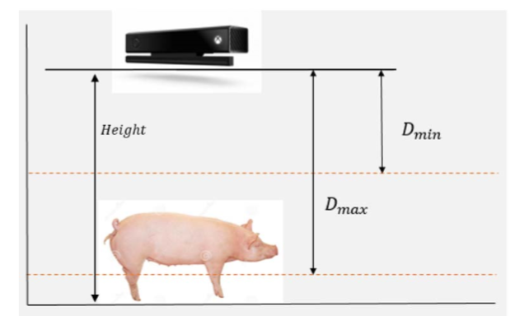

**Figure 2.13** Thresholding the depth [29]

As seen in figure 2.13, the Kinect sensor is installed at a fixed height. Set a minimum and a maximum threshold value for each pixel in the depth image, using the following equation:

$G\left(i,j\right)= \left\{255, D_{min}≤d\left(i,j\right)≤D_{max}\right\} , = \left\{\frac{d\left(i,j\right)}{16}, otherwise\right\}$ (2.4)

where $G\left(i,j\right)$ is the new pixel value, $d\left(i,j\right)$ is the depth value from Kinect sensor, $D_{max}$ is the lower threshold value and $D_{min}$ is the upper threshold value. This process ignores everything out the range of the thresholds. It reduces the risk of detecting the ground as a pig shape and provides a better resolution for object detection.

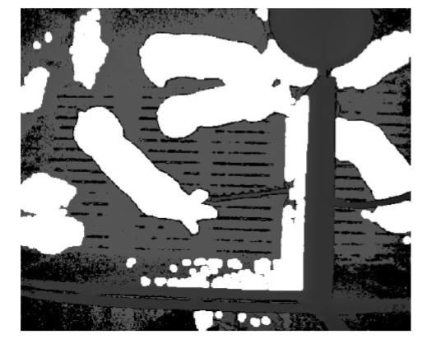

**Figure 2.14** Image after thresholding the depth [29]

It is easily to detect the white objects in the image performed after filtering depth. In this paper, an automatic thresholding method based on the gray scale histogram proposed by Otsu is invoked [30]. The detected objects are then filtered by different methods: circularity, rectangularity [31], main radius and anisometry.

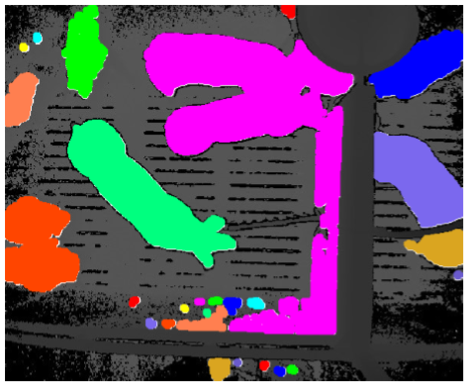

**Figure 2.15** Detected regions [29]

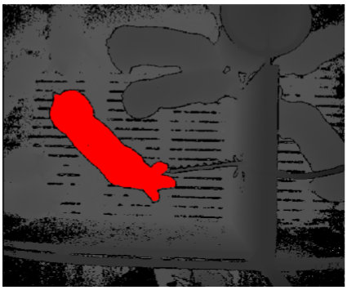

**Figure 2.16** Selected region after filtering [29]

The pig detection and selection progress example is shown in figure 2.14. There are 27 white regions detected from the image after threshold depth, which are shown in figure 2.15 with different color. After applying the filter values, the standing pig is detected successfully in figure 2.16.

**Table 2.10** Detection Results [29]

|  |  |  |  |
| --- | --- | --- | --- |
| Pig Weight | Detection Performance | | |
|  | Detection Count | Error Count | Error Percentage |
| 25 (kg) | 826 | 24 | 2.95% |
| 60 (kg) | 1098 | 22 | 2.06% |

Table 2.10 shows the detection results for different weights pigs. The error count is manually counted. Results for both types of pig have a low detection error: 2.95% for small pigs and 2.06% for larger pigs. The automatic detection count of small pigs (826 counts) is less than the large pigs (1098 counts). Besides, the detection of small pigs has more detection error count (24 counts) than the large pigs (22 counts). This is because of the small pigs are more likely to rush for food or drink, the detection method is not able to separate the contacting objects very well.

**Analyzing Egg Weight Using Image Processing**

According to Duangkamol Dangphonthong, [10] with current image processing technology, we can use digital image to estimate egg size such as in an image sorting egg. The method to be used is counting the pixels of egg image but this method causes mistakes in counting the number of pixels of egg image since it is restricted on light and shadow happening during the processing. Moreover, some eggs may have a huge area of pixel size but it may weigh less than its actual weight. Thus, the counting pixels of eggs photo cannot compare with the actual weight of the egg. Because of this, the methods for distinguishing the basic features of egg photo to analyze for an egg weight will be utilized and these are the following: color image, image sharpening, image representation, regional descriptors, computer weight and volume, and recognitions. The research used a sample size of 100 varying egg sizes. The first step, which is the color image, was used to analyze egg weight with a 3,000 × 4,000 size of pixels which caused by using digital camera to photograph the egg in vertical. As seen in Figure 2.17, the distance from the camera to the egg stand is said to be 52cm and the image of the egg was captured on different angles and sides.

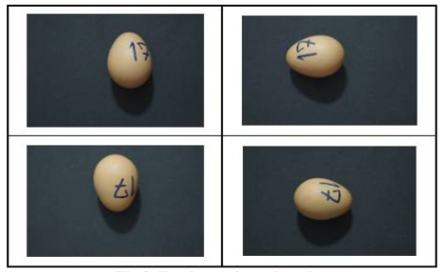

**Figure 2.17 Egg Image in each Style (color image method) [10]**

The next procedure after color image is the method involving image sharpening. The contrast of the image is adjusted by finding the position changes of the intensity of light at the position of pixel instantly so this position is the edges of the object which, using the principles Gradient, determine the edges of the object clearly.

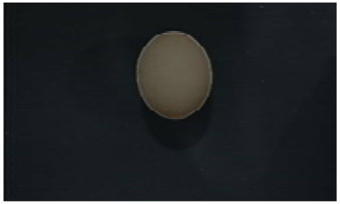

**Figure 2.18** Egg picture which specify the extent of the object (image sharpening) [10]

The third procedure involves image representation in which interrelated parts of the picture are separated to be a representative of object in the picture. Region representation is using an internal area in the picture to be an object representative. The image of the egg which specify the exact extent will be separated by using the binary values 1 and 0, binary value of 1 as the area representing the object of intent (egg) while binary 0 represents the area that is not the area of the object (background).

Image representation is followed by the next procedure which is the regional descriptors. Regional descriptor is an area representative of each object that will compromise the basic feature of the object such as its width, length, height, shape as well as its own surface. Using the formula for determining the distance between two points $\left[d\left(P_{1},P_{2}\right)= {\left(X_{2}-X_{1}\right)}^{2}+{\left(Y_{2}-Y_{1}\right)}^{2}\right]$, the distance from two pixels (ending points) which lines longest in the area of the object in x-axis plane and y-axis plane as seen in figure 2.19 to obtain the width and length of egg after that to calculate the volume and egg weight will be determined.

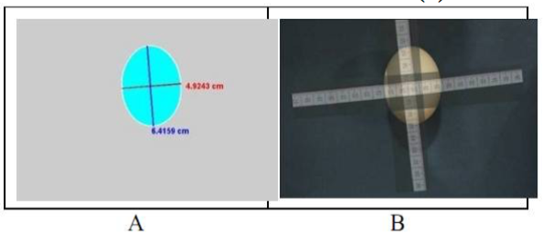

**Figure 2.19** The result of measuring the width and the length of the egg (regional descriptor) [10]

Consequently, computer weight and volume involves the estimation of the volume of an egg by measuring its length and width using the equation below that was proposed by many researchers.

$$V= \frac{11}{21}LB^{2}$$

$$V=\left(0.6057-0.0018B\right)LB^{2}$$

$$V=0.526LB^{2}$$

$V= 2.854LB$ (2.5)

Where L = length of the egg (mm); B = width of the egg (mm); V = volume of the egg (mg)

The research uses the 4th equation in estimating the volume of an egg. If analyzed in the extrapolation method, the estimated weight will be obtained through the equation 2.6 that is shown in Figure 2.20.

$M=1.1056V^{0.9923}$ (2.6)

Where M = egg weight (g); V = egg volume (mg)

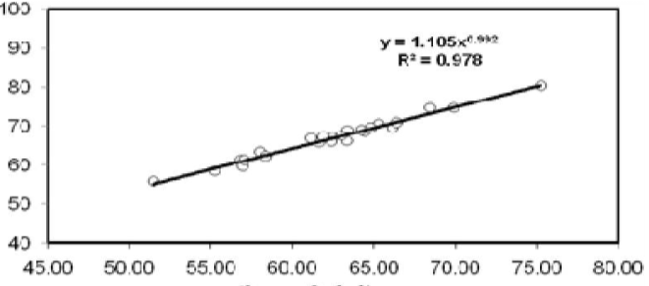

**Figure 2.20** Relationship of Weight and Volume [10]

The final procedure is the recognition. Recognitions is a step to sort egg size by weight from the analysis of egg weight compare with the agricultural commodity and food standard (ACFS 6702 – 2548) shown in Table 2.11.

**Table 2.11** Size of Egg by Weight [10]

|  |  |  |
| --- | --- | --- |
| Number | Size | Weight (g) |
| 0 | Jumbo | Upper 70 |
| 1 | Extra Large | Upper 65-70 |
| 2 | Large | Upper 60-65 |
| 3 | Medium | Upper 55-60 |
| 4 | Small | Upper 50-55 |
| 5 | Pewee | Upper 45-50 |

**Edge Detection Methods**

Edge Detection is the process of segregating and identifying sudden disruptions in an image. This sudden disconnection are changes in pixel intensity which distinguish and set boundaries to emphasize the objects in a scene. There are different methods to choose from and these methods may be formed into two categories. The Gradient Based Edge Detection operates by looking for the maximum and minimum in the first derivative of the image. While for the Laplacian Based Edge Detection, it locates the zero crossings in the second derivative of the image. Based on the study made by Maini and Dr. Aggarwal [3], it has been proved that the Canny Edge Detection Algorithm performs better than other methods using MATLAB.

**Table 2.12** Edge Detection Techniques Comparison [3] [32]

|  |  |  |
| --- | --- | --- |
| Operator | Method | Description |
| Sobel Operator | Gradient Based Method | * More sensitive to the diagonal edge than the horizontal and vertical edges. * Best in detecting only outer lines or continuous boundary of an object |
| Robert’s Operator | Gradient Based Method | * Diagonal edge gradients * Susceptible to fluctuations * Gives no information about edge orientation * Works best with binary images |
| Prewitts’s Operator | Gradient Based Method | * Similar to Sobel Operator * Make use of maximum directional gradient * Prewitt masks are simpler to implement than the Sobel * Very sensitive to noise |
| Laplacian of Gaussian | Laplacian Based Method | * Zero-crossings of LOG offer better localization, especially when the edges are not very sharp. * Does not handle corners well |
| Canny | Laplacian Based Method | * Utilizes non-maxima suppression and hysteresis thresholding * Depends heavily on the adjustable parameters * Manifest the better detector for outer and inner lines of object forming edges * Has a better immunity to noise but more expensive |

Table 2.12 shows the summary of different edge detection technique. It states which category it belongs to.

**Visual Comparison of Various Edge Detection Algorithms**

**Figure 2.21** Sample image for edge detection analysis[3]

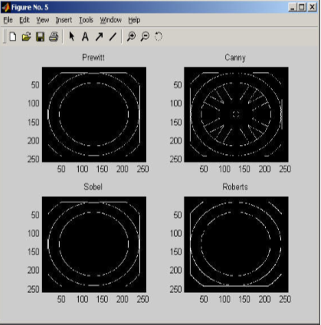

**Figure 2.22** Results of edge detection analysis [3]

Edge detection for all four types was performed and seen on Figure 2.22[3]

As we can see, Canny yielded the best results. This was expected because Canny edge detection accounts for regions in an image. Canny yields thin lines for its edges by using non-maximal suppression. Canny also utilizes hysteresis with thresholding [3].

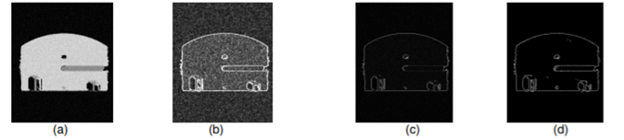

**Figure 2.23** Comparison of edge detection technique on a noisy image [3]

As seen in the figure above, (a) is the original image with noise. In (b), Sobel operator was used, (c) Robert, and (d) Canny. It is seen that the canny output image has the best quality of edge detection despite the noise compared to the other 2 techniques.

**Active Contours**

Active Contour (also known as deformable models or 'snake') is one kind of segmentation method in the field of imaging. The differences between Active Contour and other segmentation models is the process of minimizing curves in the segmentation process [2]. A contour curve is influenced by energy ($E_{snake}$) which is defined as the sum of the three types of energy as described in the equation below: [78]

$E_{snake}= E_{internal}+E_{external}+E_{contraint}$ (2.7)

The process of active contour models is by making an initial contour surrounding the object, then with the energy of an object image ($E_{external}$) will cause the curve shrink and follow the pattern of the object. The curve can be moved closer towards the object and adjust the shape of the object because of the energy on the curve ($E_{internal}$. Active contour models used in this study is not the classical active contour but using active contour without edges.

Active contour methods have become very popular in recent years, and have found applications in a wide range of problems including visual tracking and image segmentation; see [33]–[34] and the references therein. The basic idea is to allow a contour to deform so as to minimize a given energy functional in order to produce the desired segmentation; see [35]–[36]. Two main categories exist for active contours: edge-based and region-based. Edge-based active contour models utilize image gradients to identify object boundaries, e.g., [37], [38]. This type of highly localized image information is adequate in some situations, but has been found to be very sensitive to image noise and highly dependent on initial curve placement. One benefit of this type of flow is the fact that no global constraints are placed on the image. Thus, the foreground and background can be heterogeneous and a correct segmentation can still be achieved in certain cases.

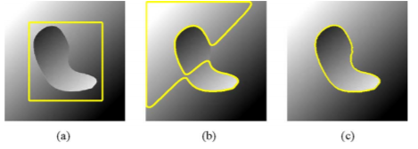

**Figure 2.24** Synthetic image of a blob with heterogeneous intensity on a background of similar heterogeneous intensity: (a) shows initializing of the contour, (b) shows unsuccessful result of an edge based segmentation while (c) shows a successful result of an edge based segmentation technique [39]

More recently, work in active contours has been focused on region-based flows inspired by the region-competition work of Zhu and Yuille [40]. These approaches model the foreground and background regions statistically and find an energy optimum where the model best fits the image. Some of the most well-known and widely used region-based active contour models assume the various image regions to be of constant intensity [41]–[42]. More advanced techniques attempt to model regions by known distributions, intensity histograms, texture maps, or structure tensors [43]–[44]. Paragios and Deriche [45] presented a method in which edge-based energies and region-based energies were explicitly summed to create a joint energy which was then minimized. In [46] and [47], Sum and Cheung take a similar approach and minimize the sum of a global region-based energy and a local energy based on image contrast. The idea of incorporating localized statistics into a variational framework begins with the work of Brox and Cremers [48] who show that segmenting with local means is a first order approximation of the popular piecewise smooth simplification [49] of the Mumford-Shah functional [50].

A well-known example of an energy that uses a constant intensity model is the Chan–Vese energy [50], which we will refer to as the uniform modeling energy:

$E_{UM}= \int_{Ω_{y}}{Hϕ\left(y\right){\left(I\left(y\right)-u\right)}^{2}+\left(1-Hϕ\left(y\right)\right)}{\left(I\left(y\right)-v\right)}^{2} dy$ (2.8)

Another important global region-based energy that uses mean intensities is the one proposed by Yezzi et al. [42] which we refer to as means separation energy:

$E_{MS}= \int_{Ω_{y}}{{\left(u-v\right)}^{2}}$ (2.9)

This energy relies on the assumption that foreground and background regions should have maximally separate mean intensities. Optimizing the energy causes the curve to move so that interior and exterior means have the largest difference possible. There is no restriction on how well the regions are modeled by $u$ and $v$.

Next, we consider a more complex energy that looks past simple means and compares the full histograms of the foreground and background. We show that its incorporation into the framework is as simple as the previous energies shown. Consider $P_{u}\left(z\right)$ and $P_{v}\left(z\right)$ to be two smoothed intensity histograms computed from the global interior and exterior regions of a partitioned image $I$ using $z$ intensity bins. The Bhattacharyya coefficient, [51] is a measure used to compare probability density functions, and results in a scalar corresponding to the similarity of the two histograms. Recently, Michailovich et al. [44] proposed an image segmentation energy based on minimizing this measure. We will call this the histogram separation energy.

$E_{HS}=B= \int_{z}{\sqrt{P_{u}\left(z\right) P_{v}\left(z\right)}} dz$ (2.10)

By using the Bhattacharyya measure to quantify the separation of intensity histograms, the global version of this flow is capable of segmenting objects which have non-uniform intensities. However, the intensity profile of the entire object and the entire background must still be separable.

**Feature Extraction Techniques**

Feature extraction can be classified into the following: low level feature extraction and high-level feature extraction. For the low-level feature extraction, small details of the image like points as well as edge corners are to be considered. In this classification, the feature can be extracted automatically without the knowledge of the shape. On the contrary, high level feature extraction are utilized to detect large shapes in the image and it is built above low-level feature extraction. In this study, the Convolution Neural Network (CNN), which uses both said features, will be used to detect lines. Edges and corners of the outline of the pig that will later be layered with common shapes and sizes. The quality of the edge extraction is very dependent on the lightening conditions, alike intensities and the presence of noise. According to a researcher named A.K Sinha, due to powerful parallel mechanism, Neural Network is a promising technique when it comes to feature extraction [18].

**Autofocus Algorithms**

There are different types of autofocusing methods that have been studied since 1990 [1]. There are two categories in autofocusing method: The active autofocus and passive autofocus. The active AF uses a sensor or measurement tool to determine the object’s distance from the lens. Although, the passive AF depends only on the image information. Different sharpness functions were studied by Loren Shih:

**Table 2.13** Comparison of Autofocus Algorithms [1]

|  |  |
| --- | --- |
| Method | Description |
| Tenegrad/Sobel | * 2D spatial gradient measurement approach for a sharpness calculation * To detect edges in the horizontal and vertical directions, larger matrix was used |
| Prewitt Gradient Edge Detection | * Similar to Sobel * Simpler matrix to detect horizontal and vertical features |
| DCT | * It is widely used in image compression * Converts the image into the spatial frequency domain * Uses an AC components as indication of the sharpness |
| DCT 4x4 | * Uses only the 4,4th component to calculate the sharpness assuming it is the most significant out of the 64 |
| Low Contrast DCT | * Scales the AC components by the total intensity of the image * Purpose is to compensate for non-uniformity in the image intensity, specifically in low contrast scenes, as the focus changes * Works well with both ordinary images and low contrast images. |
| DFM270 | * Utilize a column-wise first differences filter approach * The algorithm does not take into account horizontal variances |
| Structure Content | * It is based on the relationship between the overall image luminance versus the average image luminance |

A total of 13 scenes were selected for comparison in the study where each of the scenes were taken with different focal positions. A Canon D20 camera was used to capture set in manual focus. Some scenes were taken using demo kits with 2MP and 3MP CMOS imagers which is a prototype digital camera. All images were taken with full color images that is converted to grayscale and the resolution of most images are 1600x1200 pixels [52].

**Table 2.14** Algorithm overall fitness (accuracy and unimodality) [52]

|  |  |  |
| --- | --- | --- |
| Algorithm | Sum of Rankings | Final Ranking |
| Tenegrad | 2 | 1 |
| Prewitt | 2 | 1 |
| DCT | 8 | 4 |
| DCT 4x4 | 5 | 3 |
| Low Contrast DCT | 4 | 2 |
| DFM270 | 8 | 4 |
| Structure Content | 8 | 4 |

Table 2.14 results state that 2D spatial measurements approach such as the Sobel and Prewitt generate the best results in accuracy and unimodality.

Another algorithm studied by Xuedian Zhang, et al., based on depth from focus and depth from defocus method [53]. Both are passive autofocusing method which is widely used in the vision applications because it is simpler and less expensive.

The depth from focus methods are based on the image formed by an optical system focused on an object at a specific distance and other objects at a different distance are blurred. However, in depth from defocus method, first thing to do is to determine the focus function that describes the degree of focus at different positions and then look for the best focus position according to the focus function. The new proposed algorithm of Zhang is an improved DFD method with low computation amount and accuracy suitable for real application. There are two ways: First is by changing the image distance, the defocus distance is the distance between the current imaging plane and focal plane, this can be calculated by using two defocused images. Figure 2.25 shows the scheme of the improved DFD method by changing the image distance.

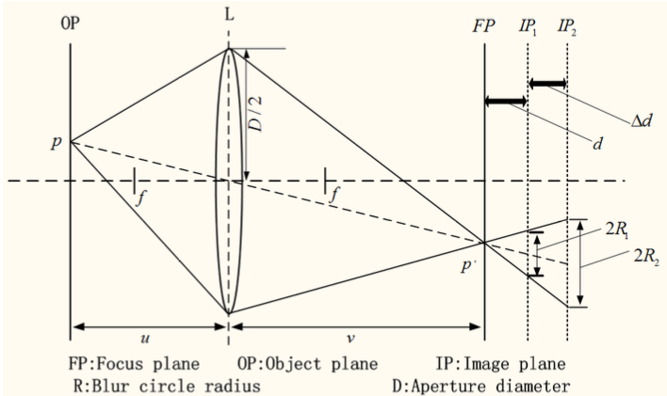

**Figure 2.25** Optical imaging model [53]

In the Figure, P is an object point on the object plane FP which is blurred within a radius of R1(R2) on the imaging plane IP1 (IP2). The radius of blurred spots can be calculated by equation 2.11.

$R=d\frac{D}{2}\left(\frac{1}{f}-\frac{1}{u}\right)$ (2.11)

Where D = Lens diameter; u = Object distance; f = Focal length; v = Image distance of the optical imaging system; and d = Distance between the imaging plane and focal plane

Another study in automatic autofocusing studied by Hashim Mir, Peter Xu, and Peter Van Beek [54]. Passive autofocus mechanisms come in two basic kinds: The contrast-detection which is the most common; while the phase-detection autofocus, which is only present in high-end DSLRs. Contrast-detection will give the most accurate focus when shooting a single-shot for still subjects [55].

**Filtering Technique**

A filtering method is necessary to clean up the segmented image, this post-processing methods involve two forms: Median filtering and Morphological filtering [12]. Morphological filtering has a wide set of image processing operations that process image based on shapes [56]. Morphological operations apply a structure element to the input image, this defines the region of interest or the neighborhood around a pixel [57]. The most basic operations are erosion and dilation.

In dilation, it adds pixels on the boundaries of the object. The value of the output pixel is the maximum value of all pixels in the input pixel’s neighborhood. In a binary image, if any of the pixels set to the value of 1, the output pixel is set to 1. While in erosion, it removes pixels on the boundaries. The value of the output pixel is the minimum value of all pixels in the input pixel’s neighborhood. In a binary image, if any of the pixels set to the value of 0, the output pixel is set to 0. The following figures will show the output of each operation.

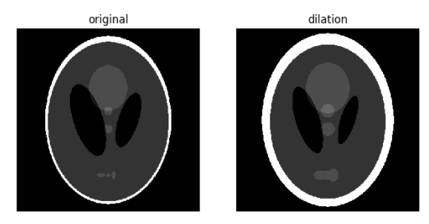

**Figure 2.26** Dilation Process [57]

In figure 2.26, the white boundary becomes dilated. The two black ellipses in the center decreases its size while the three light grey patches at the lower part enlarges.

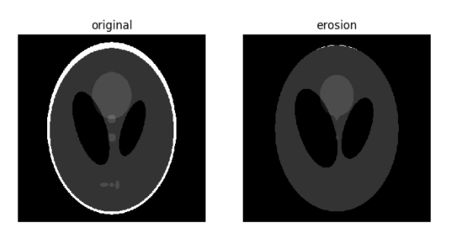

**Figure 2.27** Erosion Process [57]

In figure 2.27, the white boundary gets eroded as the size of the disk. The two black ellipses in the center enlarges and the three light grey patches at the lower part was completely vanished.

There are two operations where the combination erosion and dilation are processed. Image opening is where erosion comes first followed by a dilation. It can remove small bright spots and connect small dark cracks. It has the effect of removing clusters of 1-valued pixels which are smaller than the specified structuring element [12]. While image closing is defined by dilation followed by erosion, it can remove small dark spots and connect small bright cracks. Thus, it has the effect of removing clusters of 0-valued pixels.

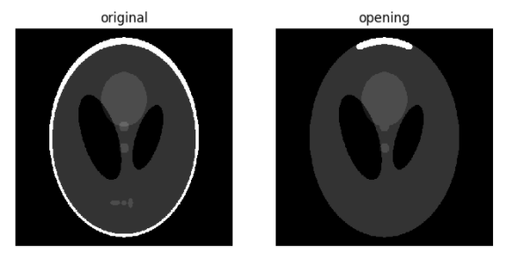

**Figure 2.28** Image Opening [57]

Figure 2.28 shows the image opening process. The process starts with erosion where light regions smaller than the structuring element were removed. Subsequently, dilation process ensured that light regions larger than the structuring element retained their original size. Notice on the figure that the light and dark shapes at the center were maintained while the light patches at the bottom part gets eroded. The size dependence is highlighted by the white outer ring. For that reason, parts of the ring thinner than the structuring element will be erased and thicker regions at the top will retain its original thickness.

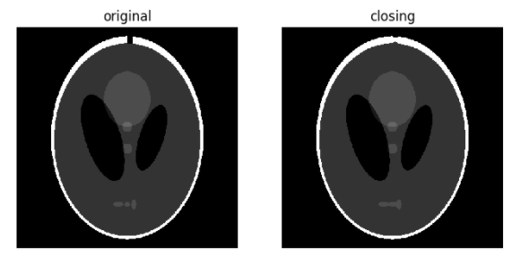

**Figure 2.29** Image Closing [57]

Figure 2.29 shows the image closing process. To illustrate the process, a small crack on the white border is present on the original image. The dark regions smaller than the structuring element are removed. The dilation that follows ensures that dark regions larger than the structuring element retain their original size. Notice on the figure that the white ellipses at the bottom part connects because of dilation, but the other dark region retains its sizes. Also, the crack added from the original image is mostly removed.

**Relationship Between Pig Weight and Dimensions**

To be able to estimate a pig’s weight through its dimensions, the relationship of the volume and weight is required to be known. A reasonable assumption is that its weight will be directly proportional to its volume. According to Schofield, there is no proven data regarding the density of a live pig but the weight of a live pig is assumed to be approximately $1000 {kg}/{m^{3}}$ which varies little with weight, as the relative proportions of bone, flesh, fat, and lungs do not change significantly over the growth rate of interest. It is useful to consider how the weight of a solid object is calculated from its dimensions in order to appreciate which of the pig’s dimensions are most likely to be closely related to its weight. For example, from the area of any one side and the length of the edge perpendicular to it. If the estimated error for any individual measurement is 3%, then the error in calculating the volume from three length measurements could be 9%. If volume is estimated from a single measurement with 3% error, it follows that better correlation should be obtained when working from an area than from a single, linear dimension, as area is more closely related to volume. By measuring an area directly (using image analysis), and relating it to volume with a suitable algorithm, the potential for errors is less than when working from linear dimensions [16].

The problem of measuring the volume of a pig is complicated, for the legs, head and ears have to be taken into account along with the body. Measuring the volume of a pig is complicated because the legs, head, as well as the ears have to be taken account along with the body which makes up the main bulk of the pig. It is possible to break down the shape of the pig into several parts and represent each approximately by a geometric shape as shown in Figure 2.30, so that the proportion each contributes to the whole can be estimated.

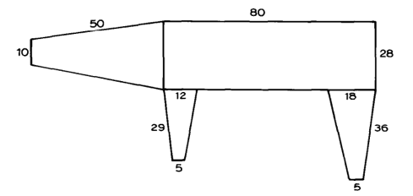

**Figure 2.30** Shape of Pig Broken Down into Several Parts: shows model of a pig constructed from cones and cylinder. [16]

In figure 2.30, volume of a cylinder can be calculated from $πr^{2}l$ and the volumes of the truncated cones from $\frac{πh}{r^{2}}\left(R^{2}+Rs+s^{2}\right)$ where r = radius of the cylinder, l = length of the cylinder, h = height of each cone, and R & s are the large and small radii of the cone ends respectively. However, the downside of this method is that the calculation of body volume can give large errors due to the difficulty defining shapes to match accurately each of the body parts. The dimensions shown in figure 2.27 were measured from the top and side images of an 80 kilograms pig, so closely represent real values. Table 2.156 gives an indication of the relative proportion of each body parts to the whole.

**Table 2.15** Estimated Volume and Percentage of Total Weight for Parts of the Model pig [16]

|  |  |  |
| --- | --- | --- |
| Part of Pig | Volume $\left({cm}^{3}\right)$ | % of Total Volume |
| Body | 49,300 | 64.6 |
| Head and Neck | 15,200 | 20.0 |
| Front leg (x2) | 3,500 | 4.6 |
| Rear leg (x2) | 8,300 | 10.8 |
| Total | 76,300 | 100.0 |

**Measurement of Pig Area to Weight Relationships (Image Data Collection)**

A set of photographic images of pigs was required from which accurate dimensional data could be measured before analysis of the relationship between area and weight could proceed. These had to show all relevant dimensions, so images from the side and from directly above each pig were required, taken simultaneously to avoid any changes in pig shape (hence dimensions) due to movement. A batch of 15 pigs were photographed on a weekly interval until the pig reached the market size of approximately 80 kilograms. This provided a collection of benchmark images which gave a record of the change in body dimensions with increasing weight over a period of 6 weeks [16].

A special pen was constructed to hold each pig in turn while photographs were taken. The pen had a floor area measuring 1.43 m deep by 1.72 m wide, so the pig had sufficient space to move and stand freely. A plate glass wall formed one of the long sides so the pig could be viewed and photographed. The top view image was obtained via a mirror, placed over the pen and angled at approximately 45”, so that photographs could be taken from as long a distance as the space within the building allowed, this being 7-4 m from the camera to the pen front. To be able to give true side elevation images, the camera height was chosen to coincide with the center height of the pig’s body and the angle of the mirror was set to reflect a vertical image to the camera by making fine adjustments to its position while looking through the camera viewfinder. This layout had the advantage of allowing both images of the subject pig to be collected in the same photograph, which was convenient for analysis. Figure 2.28 shows the design of the system.

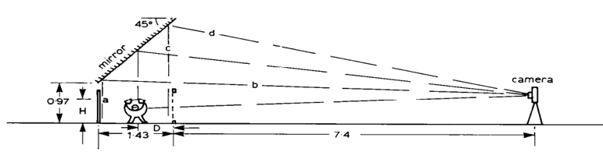

**Figure 2.31** The benchmark image collection system [16]

Figure 2.31 shows the special pen design as well as the position of the camera in capturing photographs of the pig.

The pig’s height can be calculated from the side view image and the distance from the camera to the pig [7-4 + D in the example (in m)] from the top view image. The distance from the camera to any position on the pen floor via the mirror will be the same and the distance from the camera to the pig was kept large so that any variations in pig height, and reduction in apparent area due to curvature of the pig’s body would be minimal. The system was calibrated so that the errors due to distance and other image sorting effects can be calculated. Variations in pig height were measured from the side view images and corrections were made in the area calculations using a factor derived from analysis of the geometry of the equipment [16].

After testing, the lighting for the photography was optimized using various background illuminations and colours to be able to identify which showed the best outline of the pig. For the side views the pigs were photographed against a mid-green background as this gave the greatest contrast for both monochrome and colour photography. The slatted floor of the pen formed the background for the top view images, so little control of colour was possible. The matt black of the steel slats was found to give acceptable results. Figure 2.29 shows an example of a monochrome image.

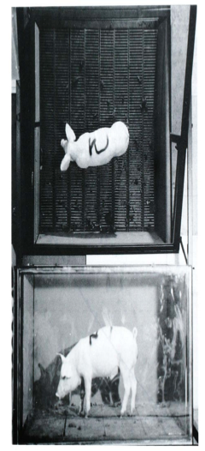

**Figure 2.32** Monochrome Image of a Pig: benchmark image showing simultaneous top and side views [16]

Immediately after the photos were taken, the pigs were weighed in a commercial spring balance weigh crate. The crate was calibrated to 50.5 kg over a range of 0 to 150 kg. Due to the pig moving while in the weigh crate, there was always some unsteadiness in the indicated weight, but repeated weighing showed that an experienced user could achieve readings with a repeatability within the calibration accuracy. As further check on weights, each pig was weighed two days prior to, and two days after each photographic and weighing session. This highlighted any abnormalities in weight at the times when the photographs were taken. These could be caused by the pig having an unusually full (or empty) stomach, for example. This effect was minimized by ensuring that the pigs were fed and weighed at the same times on each occasion (8 am and 10 to 11 am respectively) [16].

**Real Size Estimation of a Thumb**

According to Chaithanya et al., real size estimation can be done using calibration process. After preprocessing and thumb size extraction, the size of the thumb portion will be compared to the actual thumb size that is stored in the database which is measured from the thumb image. The input image is taken such that the user’s thumb is placed beside an object. In the extraction of the thumb portion from the image, first the image has to convert into YCbCrcolor space. Skin color detection and extraction is best possible in YCbCr color space. A bounding box will be drawn around the thumb as seen in Figure 2.33 and the height as well as the width of bounding box gives the measurement of the thumb portion [58].

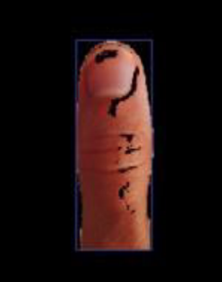

**Figure 2.33** One-time calibration of thumb image [58]

The figure above shows the bounding box around the thumb that will be essential in obtaining the thumb’s height and width.

**Weight Estimation of a Thumb**

The weight estimation of the thumb requires the following parameters to be known: mass, volume, density, and as well as the thumb’s height. After being able to extract the thumb and acquire its dimensions, the area can now be calculated. To calculate the surface area of the object, superimpose a grid of squares onto the image segment so that each square contains an equal number of pixels and, therefore, equal area. Using grid method for area calculation will match with irregular shapes. After calculating for the area, volume can now be calculated. [58] The top view image is used for area calculation and side view image is used for height calculation. The volume and mass of the object can be determined by:

$Volume=Area*Height$ (2.12)

$M=ρ*V$ (2.13)

where M is the mass of the object and ρ is its density. The density of each object is stored in the database. The output of classification phase is used to retrieve corresponding density from the stored density table. Lastly, after obtaining the required parameters, weight can now be calculated. The weight can be calculated using the mathematical equation:

$W=M*G$ (2.14)

where W is the weight of the object, M is the mass, and G is the gravitational force which has the value $9.8m/s$.

**Acceptable Percent Error in Weight Estimation**

According to an article written by Helmenstine, the amount of error that is acceptable depends on the experiment, but a margin of error of 10% is generally considered acceptable already. When an instance that the margin of error is more than 10%, the procedure implemented must be studied further to be able to identify what caused such large errors [59].

In a study conducted by Coe et al. wherein they investigated the accuracy of visual estimation of weight and height in pre-operative supine patients, they have seen in their percentage error scatter diagrams that the majority in the estimation fits within $±5\%$ error. They considered this margin of error to be acceptable [60].

In a study conducted by Velardo and Dugelay, they studied the feasibility of weight estimation from anthropometric data directly accessible from the available image material. A model is retrieved via multiple regression analysis on a set of anthropometric features. Based on their experimental results, they have considered the cumulative value for the error range $±10\%$ since this is the one considered acceptable in the medical community [62].

**Mathematical Models for Weight Estimation**

In a study conducted by Kollis, the regression equations of all the weight feature relationships are shown below, where y, x1, x2, x3 and correspond to weight, area, length, and spine length, respectively. No equations incorporating x2 x3 or x1 x3 terms are reported because there was no significant interaction between the corresponding features [12].

$y=35.051\log\left(x_{1}\right)-262.4$ (2.15)

$\log{(y)}=5.966×{10}^{-3}x_{2}+3.040$ (2.16)

$y=22.10\log{(x_{3})}-50.14$ (2.17)

$y=3.470×{10}^{-2}x_{1}+1.716x_{2}-1.690×{10}^{-4}x_{1}x_{2}-291.4$ (2.18)

This study verified that the weight of a pig could be estimated from a top-view image with an average error of around 5%.

In a study conducted by Yang and Teng, the pig’s weight is estimated by the projected areas and heights. By comparing with the real weight, the mean relative error is 3.2%. The pig weights were estimated using the following multiple regression equation after many experiments.

$W=0.003×S^{1.2811}×H^{0.6121}$ (2.19)

Where W is the estimated weight (kg) of a pig, A is specified projected image area (cm2), and H is the estimated height [1].

**Statistical Significance**

Statistical significance is an estimate of the degree, to which the true translation quality lies within a confidence interval around the measurement on the test sets. A commonly used level of reliability of the result is 95%, also written as p=0.05, called p-level. While the 95% statistical significance level is the most commonly used for historical reasons, Koehn validated the accuracy of the bootstrap resampling method at different statistical significance levels.

**Table 2.16** Validation of the statistical significance estimations

|  |  |  |
| --- | --- | --- |
| Significance Level (%) | Conclusions | Correct (%) |
| 100 | 1042 | 100 |
| 99-99.9 | 738 | 100 |
| 98-98.9 | 245 | 99 |
| 95-97.9 | 394 | 98 |
| 90-94.9 | 363 | 95 |
| 80-89.9 | 520 | 88 |
| 70-79.9 | 324 | 77 |
| 60-69.9 | 253 | 72 |
| 50-59.9 | 261 | 52 |

Table 2.16 displays the findings. For each conclusion, Koehn checks into what statistical significance range it falls, e.g., 90-94.9%). Then, he checks for all conclusions with an interval, how many are correct, i.e., consistent with the conclusion drawn from the much larger 30,000 sentence test set. The numbers suggest, that the method is fairly accurate and errs on the side of caution. For instance, when we conclude a statistical significance level of 90%-94.9%, we are actually drawing the right conclusion 95% of the time [62].

The level at which the null hypothesis is rejected is usually set as 5 or fewer times out of 100. This means that such a difference or relationship is likely to occur by chance 5 or fewer times out of 100. This level is generally described as the proportion 0.05 and sometimes as the percentage 5%. The 0.05 probability level was historically an arbitrary choice but has been acceptable as a reasonable choice in most circumstances. If there is a reason to vary this level, it is acceptable to do so. So, in circumstances where there might be very serious adverse consequences if the wrong decision were made about the hypothesis, then the significance level could be made more stringent at, say, 1% [63].

**Feature Extraction Technique**

Once the image of the pig is segmented and is cleaned up through filtering, features could now be extracted. The three features employed are the area, length as well as the spine length. The area of the object in pixels is trivially defined to be the sum of the binary pixel values over the whole image. This assumes that by this stage there will be only one contiguous region in the image. The spine length feature does not refer to the actual spine of the pig but to the major branch of the tree structure which can be found by performing skeletonization on the binary image. Skeletonization is defined as the process which reduces the objects in the image to lines without changing the vital structure of the image thus making it a representation of the topology of an object [12]. Skeletonization can be performed via MATLAB.

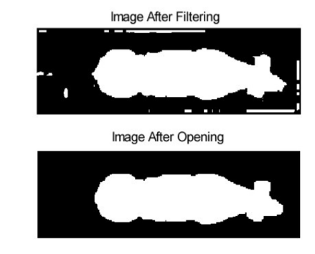

**Figure 3.34** Image after Filtering and Image Opening: shows the image of the pig before skeletonization. [12]

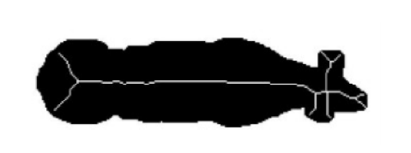

**Figure 3.35** Skeletonization Performed on a Segmented Image [12]

In implementing skeletonization, as seen in figure 3.35, the skeleton will be superimposed on the negative of its corresponding segmented image to better display skeletonization process. The number of pixels that will comprise the longest branch of skeleton will be considered as the spine length. This feature is expected to be sturdy to the pig’s posture because the distance along the spine of an animal remains relatively constant regardless of curvature, and the main junction points of the skeleton remain relatively constant when the animal moves its head. This feature, which is the spine length, can be computed by isolating the largest branch in the skeleton and counting the number of pixels. The main branch can be located by determining the location of junctions through a zero-crossing method. The length feature refers to the distance from the center of the pig’s neck to its tail. It is hard to determine the position of the pig’s neck due to the reason that the orientation of the pig’s head is unknown. Thus, the pig’s neck position is estimated as the point at which the main segment of the pig’s skeleton terminated [12].

**Determining a Pig’s Length using Euclidean Distance**

After skeletonization, the two endpoints of the spine will be found. The ‘head’ endpoint was said to have the most sub-branches as it is more topological in complex and usually produce more structure sub-skeleton. On the contrary, the tail was assumed to have the most extreme pixel of the segmented image. With these two data points, the Euclidean distance can now be found. Euclidean distance could give a close approximation of the length of the pig and can also be obtained using MATLAB. Euclidean distance was appropriate since the pixel dimension ratio was one-to-one, meaning, the width of a pixel has an equal ratio compared to the height of the pixel. Since the pig is constrained to be oriented in the same direction as the image X axis the effect of uneven scaling on the X and Y axes would likely be minimal and the Euclidean distance would be a good approximation for the actual distance [12].

**Obtaining the Dimensions of an Object Using OpenCV**

Measuring an image size is similar to computing the distance from the camera to an object. In both cases, a ratio that will measure the number of pixels per a given metric needs to be defined. The first step in determining the size of an object in the image is calibrating the reference object. The object that will be used as a reference should have the following properties: First, the dimensions of the reference object should be known and has to be in a measurable unit (such as centimeters, millimeters or inches). Secondly, the reference object should be uniquely identifiable in some manner, meaning, the reference object should easily be found either based on the placement of the object (such as the reference object always being placed at the top-left corner) or as a means of appearances (such as the object being 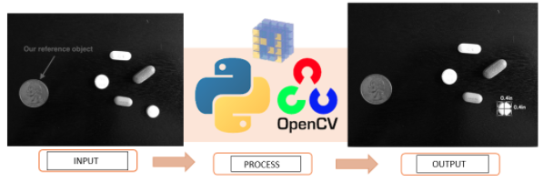distinct in color, shape that is unique and different from the other object in the image) [64].

**Figure 2.36** Measuring the dimensions of an object using OpenCV: shows the input, process as well as its output [64]

Figure 2.36 shows the reference object, which is the United States quarter, that is guaranteed to be at the left-most side of the image so that the object contours can be sorted from left-to-right (since the reference object is at the left and should always be the first to be contoured in the sorting list) and the reference object will be used to define the pixels-per-metric ratio (pixels_per_metric = object_width/know_width). A United States quarter has a know_width of 0.955 inches and suppose that an object_width, which will be measured in pixels, is computed to be 150 pixels wide (based on its associated bounding box). Hence, the pixels-per-metric ratio of the reference object will be 157 px, implying that there are approximately 157 pixels per 0.955 inches in the image. After identifying the pixels-per-metric ratio of the image, the Python driver script can now be implemented to measure the dimensions of the objects in the image [64].

**Figure 2.37** Measuring the dimensions of object using OpenCV: shows the pseudocode summarizing the process of obtaining the dimensions [64]

However, before implying this, the image should first be loaded and converted to gray scale and the preprocessing methods should first be applied. After which, the contours will now be sorted from left-to-right, allowing the extraction of the reference object. The output will show the resulting dimensions that will later be used in the calculation process. To ensure that the accuracy of the object measurement is roughly 100%, the two approaches should be considered: first, the angle between the object and the camera should have a 90-degree view so that the dimensions of the object will not appear distorted. Secondly, the intrinsic as well as the extrinsic parameters of the device should be calibrated because without determining this parameter, the photos taken will be prone to radial and tangential lens distortion. Performing this calibration is significant since this will lead to better object size approximation [64].

In the part where the side view of the pig will be taken, the measurement of the heart girth will then be obtained after conducting the procedure in getting the dimensions. According to Jonathon Burke et al., [65] the most significant measurement common to all studies of weight estimations, heart girth appears to be the single parameter which correlates best with body weight. The measurement of heart girth has been used successfully in measuring the weight of cattle, horses, pigs, sheep, and goat. Heart girth measures the circumference in the chest region as close to the forearms as possible.

**Obtaining the Area of an Object using OpenCV**

After obtaining the dimensions of the object, the area will now be calculated. Imaging systems offer a means of obtaining the area of any object for which the perimeter can be defined. The area of an object is said to be proportional to the number of squares (pixels) required to cover the area accommodated by the perimeter. According to Schofield, it is possible to be able to measure the area to within ±1% if these procedures are taken into account: first, the perimeter should be accurately defined and second, a sufficient amount of samples should be taken [16]. Area calculation can also be done using OpenCV but only after the preprocessing methods to be able to define the perimeter and the pixel count should first be acquired.

**Using MATLAB to Measure the Diameter of an Object within an Image**

MATLAB is a high-level language and interactive environment for computer computation, visualization, and programming. Image Processing Toolbox is an application available for use in MATLAB, which provides a comprehensive set of reference-standard algorithms, functions, and apps for image processing, analysis, visualization, and algorithm development. The first process is to import an image by opening the MATLAB software and in the application section, download the Image Processing Tool Box. After, a new MATLAB script file should be created. Next step, the image should be segmented. A code can be followed to segment the image into a binary image to differentiate the background from the desired objects. The first step taken is to divide the image into three images based on the intensities of each red, green and blue component within the image. This is Color Based Image Segmentation [66].

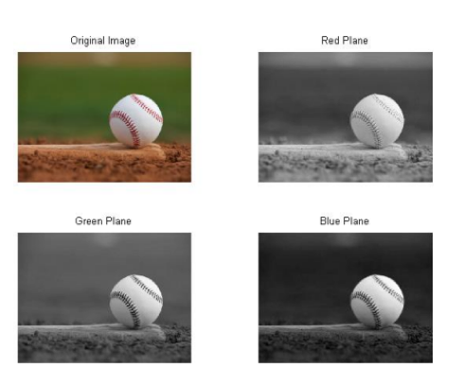

**Figure 2.38** Color Thresholding [66]

Figure 2.38 shows that the blue plane is the best choice to use for Image Thresholding because it provides the most contrast between the desired object (foreground) and the background. Image Thresholding takes an intensity image and converts it into a binary image based on the level desired. A value between 0 and 1 determines which pixels (based on their value) will be set to a 1 (white) or 0 (black). To choose the best value suited for your application right-click on the value and at the top of the menu and select “Increment Value and Run Section”. Set the increment value to 0.01 and choose the best value at which to threshold. Figure 2.39 shows the result of the Image Thresholding at 0.37.

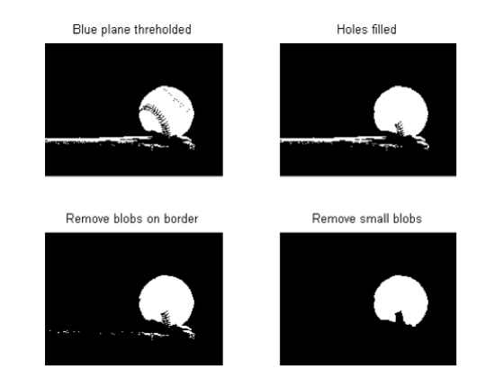

**Figure 2.39** Complete Segmentation and Cleanup Image [66]

It can be seen in the top-right of figure 2.39, that the image has been segmented between the object we desire to measure and the background. Also, it can be seen from the top-left image that there is quite a bit of “noise” and we need to clean the image up significantly to improve the accuracy of our diameter measurement. Next step is measuring the image. The image in the bottom-right corner is the result of all image segmentation and cleanup procedures to provide one distinct and cohesive blob, which represents the ball in the original image. Having the original image in a binary form such as this will make it easy for other functions built into MATLAB to quickly analyze the region and a host of different information. The regionprops function is the tool that will provide the MajorAxisLength of the blob in the image. Finally, the result will be seen.

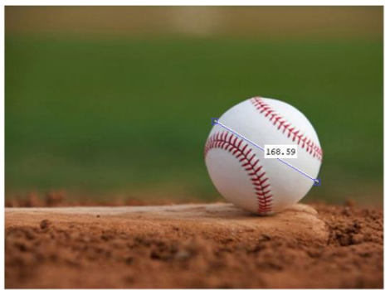

**Figure 2.40** Original Image Manually Measure [66]

Figure 2.40 shows the result wherein the diameter is now displayed in the Command Window to be approximately 170 pixels across. This was verified by using the imdistline function.

**Computer Vision Techniques in Estimating the Object Size from Static 2D Image**

The height at which the object appears in the display area of the image depends on the distance of the object from the camera. The real distance of the object from the camera consists of the distance between the object area and the lower border of the display area, and the distance not captured by the camera. Presumption is to have two images, one with and one without the object. Subtraction using RGB color model is used as the first part of the process. Every pixel of second image is subtracted from a pixel with same position on the first image. This subtraction removes the background, as it was identical in both images. Thresholding, technique frequently used tool to separate the object area and the background, is used to binarize the image. The result is a white area of the object and a black area of the background. To retrieve more accurate results following the fuzzy logic, it is suitable to use a smoothing algorithm. A median filter is used as it gives the best performance in processing pictures with black and white areas, Marchand-Maillet and Sharaiha. Canny edge detector is used to find edges after smoothing the picture. The following step requires to acquire the displayed distance between edges of the object area. These values can be determined if the object is marked by a bounding box and a circle, to obtain a minimal rectangular and circular area which the object occupies. The size of the object will be represented by two numerical values – the width and height of the object area (or one if a circular diameter is chosen). These values will characterize the entire object; thus, they represent the maximal horizontal and vertical distances between the edges of the object [67].

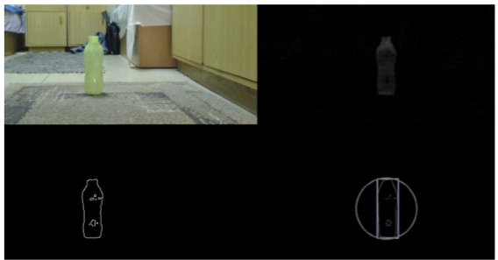

**Figure 2.41** Image processing: original image (the upper-left corner), removed background (the upper-right corner), Canny filter (the bottom-left corner), bounding box of the object (the bottom-right corner) [67]

Suitability of the shape of the bounding area is determined by a comparison of the amount of the background it covers. The bounding shape containing less background area is to be chosen. In figure 2.41 is depicted the example of both shapes of bounding areas. The size of the bounding area and a position of the area in the picture are used to calculate the physical dimensions of the measured object. The horizontal location of the object area in display, herein referred to as yPos (see figure 2.42), represents the number of pixels that separate the lower borders of the bounding area from the bottom edge of the display window [67].

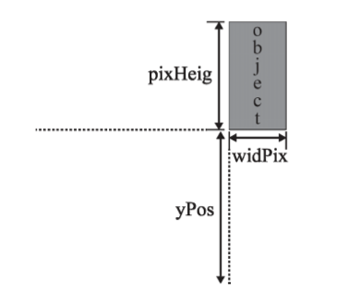

**Figure 2.42** Position of the object in the display window [67]

Several sets of tests were performed to compile equations. Each set varies in the size of the object or the height from which the camera was shooting the scene. At least four tests with different distances from the camera were taken in each set. The size of the displayed object depends on the ratio of the height from which the camera takes photos and the distance of the object from the camera. It is possible to add advanced settings for more precise definition of the object, e.g. enter more accurate setting of the physical height of a camera that takes photos [67].

**Raspberry Pi 3**

The Raspberry Pi 3 Model B is the latest version of Raspberry Pi computer. It is a credit-card sized electronic board. The Raspberry Pi 3 Model B appears to be physically identical to the Raspberry Pi 2 Model B. It has the same port selection, the same GPIO pin layout, the same basic board layout, et cetera. Pi 3 is just as significant as the prior upgrade, supercharging performance even further and eliminating what few lingering setup hassles remained in the Raspberry Pi formula, maintaining the same price point. But it is the most convenient and powerful Raspberry Pi.

The card-sized Raspberry Pi 3’s newfound power lies in upgrades: A new system-on-chip (SoC) with more potent graphics and computing capabilities, onboard 2.4GHz 802.11n Wi-Fi, and onboard Bluetooth 4.1/Low Energy support. An integrated Wi-Fi exists which requires for Wi-Fi adapter or hardwire your board via an ethernet connection. [68]

**Raspberry Pi Camera Module v2**

The Raspberry Pi Camera Board v2 is a high quality 8-megapixel Sony IMX219 image sensor custom designed add-on board for the Pi. It features a fixed focus lens. It attaches to the Pi by one of the small sockets on the board's upper surface and uses the dedicated CSi interface designed for interfacing to cameras. The upgraded Raspberry Pi Camera board v2 has improved Resolution with 8-megapixel native resolution high quality Sony IMX219 image sensor and the camera is capable of 3280 x 2464-pixel static images. For Remaining High Quality, it can capture video at 1080p30, 720p60, and 640x480p90 resolutions. All software is supported within the latest version of Raspbian Operating System. It has 1.12 µm X 1.12 µm pixel with OmniBSI technology for a high performance (high sensitivity, low crosstalk, low noise) and an Optical size of 1/4". [69]

**Raspberry Pi 7" Touchscreen Display**

The Raspberry Pi 7" Touchscreen Display adds an interactive visual capability to the Raspberry Pi. This 7” Touchscreen Monitor gives users the ability to create all-in-one, integrated projects such as tablets, infotainment systems and embedded projects. The 800 x 480 pixels display connects via an adapter board which handles the power and signal conversion. It has a screen Dimensions of 194mm x 110mm x 20mm (including standoffs) and a viewable screen size of 155mm x 86mm.

Only two connections to the Pi are required; the power from the Pi’s GPIO port and a ribbon cable that connects to the DSI port that is present on all Raspberry Pi’s. Touchscreen drivers with support for 10-finger touch and an on-screen keyboard will be integrated into the latest Raspbian OS for full functionality without a physical keyboard or mouse. Its use can make ‘Internet of Things’ (IoT) devices including a visual display. Develop a Python script to interact with the display, to make your own home automation devices with touch screen capability. [70]

**Chapter 3**

**Swine Weight Estimation Using Various Image Processing Techniques**

**METHODOLOGY**

In this part of the paper, the methodology of making a device that will approximate the weight of the pig with the use of a camera and image processing techniques as well as the experimental method in acquiring the weight of the pig will be discussed.

**Figure 3.1** Conceptual Framework

The input will be the age of the pig followed by the image. Before taking a picture, the user must input the age of the pig that they want to measure for the device to estimate the weight. A proposed Graphical User Interface (GUI) will be created with the use of MATLAB. Here, the user will be given the option to input the age of the pig that they want to measure. The whole system will consist of the following: A Camera Module v2 will be used for capturing the pig to be weighed digitally; a Raspberry Pi 3 where it will be coded for the, image segmentation and edge detection as well as the feature extraction; calculations will be done with MATLAB; an LCD will display the pig’s weight as well as its classification; and an SD card that will store the physical data. The physical data will be measured manually by the researchers. After the image has been processed using the proposed image processing technique, the proposed GUI will display the captured image, weight classification, and the estimated weight of the pig. This will be the end of the whole process.

**Table 3.1** List of Materials

|  |  |
| --- | --- |
| Component | Description |
| **Camera Module v2**  https://lh6.googleusercontent.com/Xyaa0oUEeeSUCXhEwk6IpczT20FAWhf_y0UGTNO7kc95dNC1S74JXmzuJrzDCqeJFDq0-1_X79Braqh0bGBaNqdBsW4ClvznszfFaRoWy3nkAKYBu0EPcmECGuogOzHnMFAdAm6k | This device utilized IMX219 image  sensor from Sony. It weighs 3g and has 8 Megapixel resolution. The sensor resolution is 3280 x 2464 pixels, and a sensor image area of 3.68 mm x 2. 76 mm. It also has function feature such as automatic exposure control (AEC), automatic white balance (AWB), automatic black level calibration (ABLC), and automatic luminance detection. |
| **Raspberry Pi 3**  https://lh3.googleusercontent.com/-5lRAinyfiJFqsVXXqdBnZ0oFXJGc7GpRuf77jvHDEUUYtRkkK3XeoWJbDtbrlOrPnIdcNMSnAVEuhCnyxDaaP9YqVCLym6t_tAS7gCZ2X_hjZI-fqfXzwuZEzqx0-l-L4dLllKC | The Raspberry Pi 3 is the third generation Raspberry Pi. It has 1GB of RAM and 40-pin extended GPIO. It also contains a CSI camera port for connecting a Raspberry Pi camera and a DSI display port for connecting a Raspberry Pi touchscreen display. |
| **Raspberry Pi LCD Touch Screen**  **https://lh3.googleusercontent.com/V3X9UESflk66ZAE95yjcF8M8yfuaH7cyqch2sihqfZTKKyxMDftE1OgZzViuqFZAxv5KaaF5xikku-tf6y3X7D_ghnxtXdw0QuCDGmdOcZd2069Cp7PDuvDfRfPuxLfhh91LCu4O** | A device that allows the user to enter the necessary information and save all the data in the SD card. This LCD Touch Screen is a multi-touch screen that supports up to 10 finger touches. It has 7-inch diagonal display and 800 x 480 pixels resolution at 60 frames per second. With its touch screen feature, the gathering of data will be smooth, and it can be easily transferred to the Raspberry Pi’s SD card. |
| **Micro SDHC Card** | A 32 GB SD Card will be inserted in the Raspberry Pi for storage of physical data as well as loading the operating system. The SanDisk Micro SDHC card have superior transfer rates in a high-quality design. The micro size makes it perfectly suitable for Raspberry Pi boards. Due to its ultra-small size, it consumes little power and makes the battery life longer. |
| **Power Supply Expansion Board** | The power module is designed for Raspberry Pi 3 Model B specially. It allows the master board to work offline for up to 9 hours. It's not only supplying for Raspberry Pi, but this board has 2 USB type-A ports. One supplies power for the Raspberry Pi, the other for the embedded LCD screen. The module integrates a Li-ion battery charger IC, a boost management chip. It is developed in strict accordance with the size of the international Raspberry Pi expansion board HAT, using only simple copper standoffs to install the multi-layer Raspberry Pi boards. |
| **Lithium Ion Polymer Battery** | Lithium ion polymer (Lipoly) batteries are thin, light and powerful. The output ranges from 4.2V when it is completely charged to 3.7V. The battery has a capacity of 2500mAh. The included protection circuitry keeps the battery voltage from over-charging or being overused which means that the battery will cut-out when completely dead at 2.8 V. |

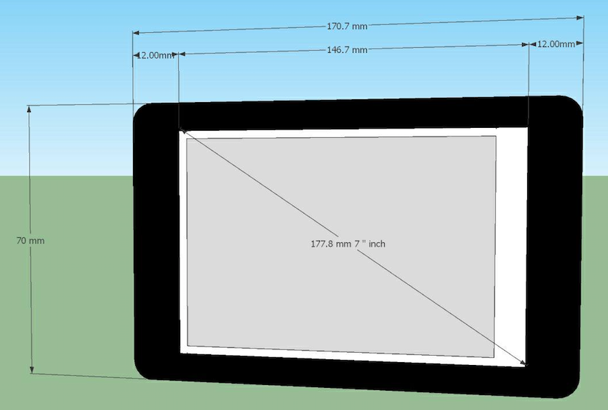

**Figure 3.2** Prototype Design External View

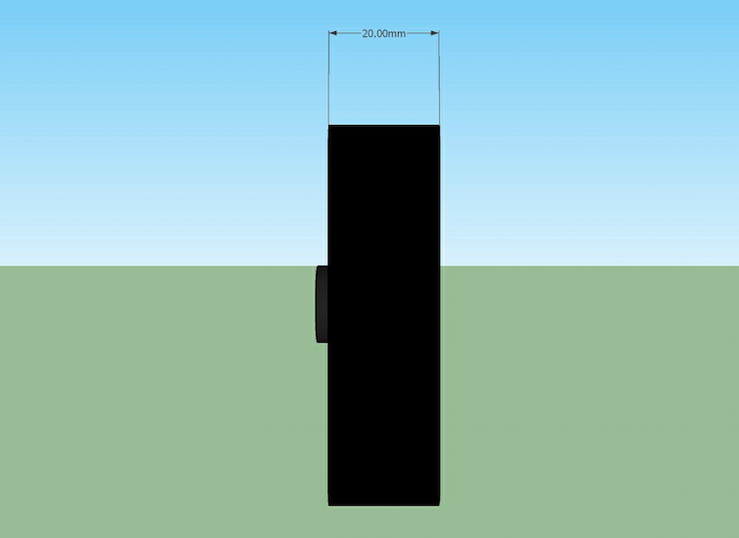

**Figure 3.3** Prototype Design Side View

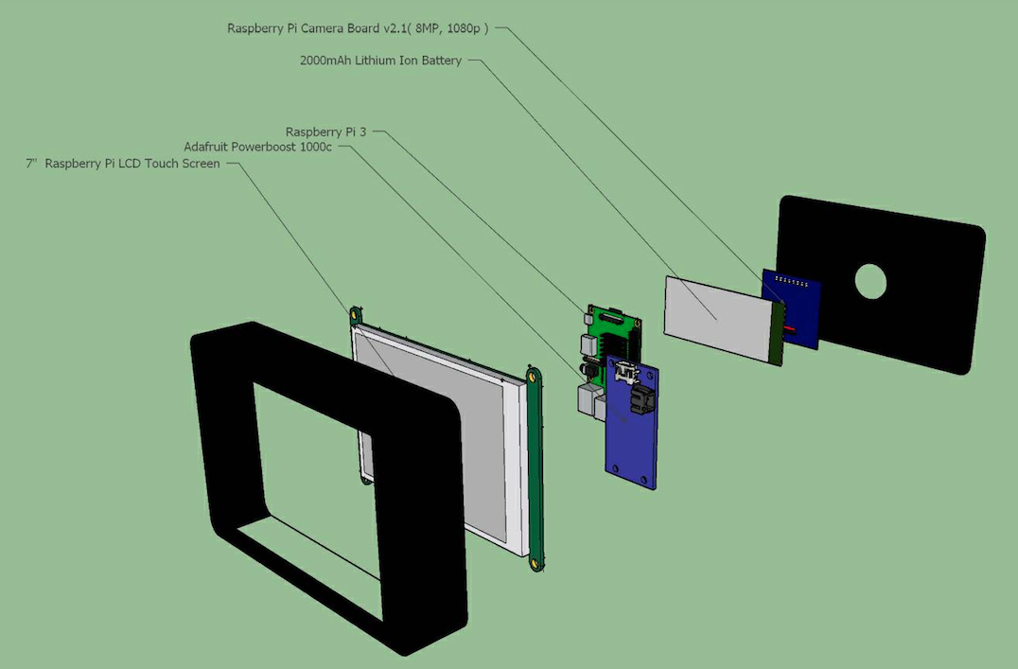

**Figure 3.4** Prototype Design Exploded View

The prototype design will compose of raspberry pi camera module v2, raspberry pi 3, 7-inch LCD touch screen, Micro SDHC card, Power Supply Expansion Board, and a lithium ion battery. The raspberry pi will execute the whole process in estimating the pig’s weight. After the weight has been calculated, it will undergo classification with the data stored in the device. The estimated weight and classification will be displayed on the LCD of the device.

1. A Power module is used to run off the lithium ion battery (3.7/4.2V kind) with 2500mAh capacity, this battery can be inserted in the empty space of the shield. It can be recharged via microUSB jack.
2. The Raspberry Pi camera module v2 will be used to capture image of the pig. The Raspberry Pi 3 will operate as the main microcontroller.
3. The SD Card would be used for storage of data and images.
4. The estimated weight will be displayed on the left side and the classification will also be displayed at the right side of the LCD. The LCD is a touch screen which will let the user input some required data.

**Calculations Process**

Autofocus the pig's image only (object detection)

Yes

Linear Regression Calculation

Is the image focused?

Calculated Weight

Classification of the Calculated Weight

No

Pre-processing which includes image normalization to filtering

The Linear Regression Equation

**Figure 3.5** Flowchart of Calculation Process

Before taking shot of the images, an autofocusing method will be applied. This will inform the person if the camera is in the most suitable position and alignment to take the photo. If the image of the pig is not focused, the system will require the user to retake the shots. It will only accept the image if it is focused. The image will be stored for the processing. After detecting the pig, it will process through an edge detection method and this will segregate the pig from the unwanted part of the image. There will be filtering technique to clean up the unwanted pixel completely. The features will be extracted from the segmented outline of the pig. Then, the pig’s image will be processed in the microcontroller. By gathering the data needed, calculations will be made. A physical stored data is generated for comparison and classification. The data will be displayed through the LCD showing the calculated weight of the pig and indicating its classification.

To address objective (a) in this study, the researchers will model an equation for the weight of the pig where there will be several independent variables that will be considered to calculate for the weight of the pig, which is the dependent variable. Since in this case, there are many independent variables such as body length, body height, chest circumference, and body area and only one dependent variable which is the pig’s weight, we will be considering the mathematical model shown below:

$y=a_{0}+b_{1}x_{1}+b_{2}x_{2}+…+b_{n}x_{n}+e_{ij}$ (3.1)

Where y is the weight of the pig which is the single dependent variable in this equation, $x_{1},x_{2},{…,x}_{n}$ are the independent variables; $e_{ij}$ is the environment error term; $a_{0}$ is the constant term; and $b,b_{2},{…,b}_{n}$ are the regression coefficients. The researchers want to relate the weight of the pigs to their body height, chest circumference, body length and body area.

**Figure 3.6** Experimental Framework

The first process in this study is the gathering of physical data to be stored in the device. This data will then be used for comparison of the estimated weight by the device. A number of 100 pigs from the piggery will be used in this process. They will be manually measured using measurement tools such as weighing scale and tape measures. The measurements that will be gathered are the actual weight, body length, body height, chest circumference and body area of the pig. Data that will be gathered from this process will be essential in the weight calculation process and the weight classification.

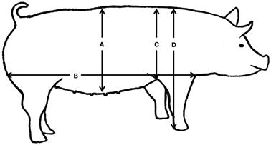

**Figure 3.7** Body Conformation Measurements in the Pig [71]

Body conformation measurements in the pig including abdominal circumference at the navel (A), the length of the body from rump to the front of the shoulder blade (B), shoulder height (C), and thorax height (D). The length of the pig’s body is measurable from the endpoints of line segment B. The pig must be standing or restrained in such a position shown in figure 3.2 for the calculations to be accurate. The circumference of the pig is measurable using the distance C. The girth must be measured in relative to the location of the pig’s heart. Using the acquired measurements, the weight of the pig can be calculated using the formula: $W= C*C*L_{AB}$. The unit of measure for the weight will be in kilograms while the lengths will be in centimeter. If the calculated weight is less than 150 pounds, we must add 7 pounds for more realistic data.

**Table 3.2** Actual Body Measurements of samples According to Age

|  |  |  |  |  |  |  |  |  |
| --- | --- | --- | --- | --- | --- | --- | --- | --- |
| Age (weeks) | | Abdominal Circumference (cm) | Body Length (cm) | Shoulder height(cm) |  | Thorax height (cm) |  | Weight  (kg) |
|  |  | |  |  |  |  |  |  |
|  |  | |  |  |  |  |  |  |
|  |  | |  |  |  |  |  |  |
|  |  | |  |  |  |  |  |  |

In table 3.2, these measurements will be gathered by manual acquisition. A tape measure will be used to get the actual body dimensions of the pig with respect to their age. All units will be in centimeters.

**Linear Least Square Regression**

The researchers will relate the weight of the pig to the area of the pig in pixels, as well as the body length (neck to tail distance) of the pig. Results will be obtained by using any of the parameters with their respective correlation of coefficients to determine the weight. These correlation coefficients will be significant if they have a probability of occurrence that is less than 1%. A scatter plot showing the comparison of parameters with a fitted regression line will be shown. The researchers would like to fit a simple linear regression model:

$y=β_{0}+β_{1}x+ε$ (3.2)

The researchers will obtain estimators for the unknown population parameters $β_{0}$ and $β_{1}$ as well as the variance of the errors $σ^{2}$.

$X^{2}=\frac{1}{σ^{2}.}\sum_{i=1}^{n}{{\left(y_{i}-f\left(x_{1i},x_{2i},…,x_{1i};a_{1},a_{2},…,a_{m}\right)\right)}^{2}}$ (3.3)

where σ is the common standard deviation in y. Minimizing $X^{2}$ is now a matter of finding the values of ($a_{1},a_{2},…,a_{m}$) that minimize the summation on the right-hand side of Equation 3.11.

**Lagrange Interpolation**

Another way to create a mathematical model is by Lagrange interpolating polynomials. This study will focus on the problem of constructing a polynomial that fits the given data which is the pig’s body length and chest circumference, area, weight, and age but this study might not be able to furnish all. First, consider some algorithms for computing the unique polynomial $p_{n}(x)$, which is called the interpolation polynomial of the data $(x_{0},y_{0})$, $(x_{1},y_{1})$,…, $(x_{n},y_{n})$, of degree $n$ that satisfies $p_{n}\left(x_{i}\right)=y_{i}$, $i=0$,…, $n$, where the points $\left(x_{i},y_{i}\right)$ are given. The points $x_{0},x_{1},…,x_{n}$ are called interpolation points. At first, assume that the interpolation points are all distinct. Then, the process of finding a polynomial that passes through the points $\left(x_{i},y_{i}\right)$, $i=0$,…, $n$, is equivalent to solving a system of linear equations $Ax=b$ that has a unique solution. However, different algorithms for computing the interpolating polynomial use a different $A$, since they each use a different basis for the space of polynomials of degree ≤ $n$. The matrix $A$ in Lagrange interpolation is simply the identity matrix where the interpolating polynomial is written in the form

$p_{n}\left(x\right)=\sum_{j=0}^{n}{y_{j}L_{n,j}\left(x\right)}$ (3.4)

Where ${\left\{L_{n,j}\right\}}_{j=0}^{n}$ have a property,

$L_{n,j}\left(x_{i}\right)=\left\{\begin{aligned}1 if i=j \\ 0 if i≠j\end{aligned}\right.$ (3.5)

The polynomials $\left\{L_{n,j}\right\}$, $j=0$, …, $n$, are called the Lagrange polynomials for the interpolation points. They are defined by

$L_{n,j}\left(x\right)=\prod_{k=0, k≠j}^{n}{\frac{x-x_{k}}{x_{j}-x_{k}}}$ (3.6)

Where $∏$ designates the “product of” (continuous). As the following result indicates, the problem of polynomial interpolation can be solved by using Lagrange polynomials.

To address objective (b), parameters will be extracted from the pre-processed image using the proposed image processing technique. These parameters will be used later for weight estimation calculation.

**Table 3.3** Comparison of actual value and estimated value of extracted features

|  |  |  |  |
| --- | --- | --- | --- |
| Parameters | Estimated Value | Actual Value | % error |
| Abdominal Circumference(cm) |  |  |  |
| Body Lenght(cm) |  |  |  |
| Shoulder height(cm) |  |  |  |
| Thorax Height(cm) |  |  |  |

As seen in the table above, the researchers will be comparing the estimated values and the actual values of the parameters needed for weight estimation. The column for the estimated value will be filled up by gathering the data that will be yielded by the proposed image processing technique. This then will be compared to the corresponding actual values of these parameters. To verify whether the estimated value is an acceptable value, the percent error must be at least 5%. To further verify if there is no significant difference between the actual values and estimated values, a t-test will be conducted.

**Table 3.4** Relation of image perspective with pig’s weight

|  |  |  |  |  |
| --- | --- | --- | --- | --- |
| Image Perspective | Estimated Weight (kg) | Actual Weight (kg) | | %error |
| Side-view only |  |  |  | |
| Top-view only |  |  |  | |
| Side-view and Top-view |  |  |  | |

In table 3.4, the researchers will relate the image perspective to the pig’s weight. Once the device estimates the weight of the pig using a side-view perspective, the researcher will get the percent error of the estimated weight to the actual weight. The device will repeat this for top-view and the combination of both. This table will show the best perspective to take for more accurate weight estimation results.

the set-up will consist of three views: Side, Top, and combination of the two. In figure 3.7 and figure 3.8, the device should be placed at a distance where only the image of the pig will be focused. This distance is set by the autofocusing process of the device. In table 3.6, the estimated weight and actual weight will be observed based on the views used to capture the image. The lowest percent of error will indicate which perspective yields the best result.

**Set-up**

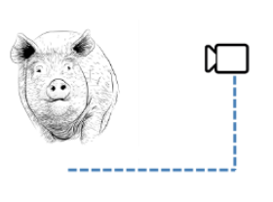

**Figure 3.8** Side View Set-up

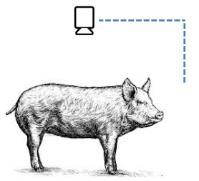

**Figure 3.9** Top View Set-up

To address objective (c), pigs are classified according to a specific range of weight. These data are actual measurements according to the owner of the piggery. The pigs were weighed by using a hanging device that measures the weight of the pig in kilograms. These data will be considered physical data and will be stored in the device for comparison.

**Table 3.5** Pig Classification According to Weight based on samples in farm

|  |  |
| --- | --- |
| Classification | Weight (kg) |
| Overweight | More than 125 |
| Normal | 75 to 125 |
| Underweight | Less than 75 |

The table above will be a reference for the classification of the pig’s weight. It is obvious that if pig weighs less than 75 kilograms, it is already classified as an underweight pig. On the other hand, if the pig weighs more than 125 kilograms, it is classified as overweight. The normal weight range according to the owner of the piggery E.S. Antonio Poultry and Piggery Farm is between 75 and 125 kilograms.

**Table 3.6** Pig Classification According to Weight

|  |  |  |
| --- | --- | --- |
| Sample | Weight (kg) | Weight Classification (Underweight, Normal, Overweight) |
| Pig 1 |  |  |
| Pig 2 |  |  |
| Pig 3  .  .  . |  |  |

After the pig’s weight has been estimated using the proposed image processing technique, the device will now classify this estimated weight whether it is overweight, normal or underweight based on the stored dimensions with its corresponding ideal weight. In this table, data will be obtained by comparing the estimated weight by the device to the actual weight of the pig with the same dimensions. The device will find the range that the estimated weight belongs. After this, the device will know what classification the estimated weight belonged to.

**Pre-processing**

Conversion to Greyscale Color Space

Edge Detection

Image Normalization

Active Contour (Snake Method)

Filtering (Image Opening)

**Figure 3.10** Pre-processing

The algorithms involved in pre-processing the image taken after the auto focusing process are shown in figure 3.10.

**Autofocus Process**

The study will include an autofocusing process to sharpen the pig’s image and blur out the background of the image. The aim of this algorithm is to automatically adjust the lens of the camera to its right position so that the image is well positioned at a focal plane. [72] AF is a key factor that affects the sharpness of the final captured image. If the image is in an out of focus position, it will become blurry indicating the user to adjust the camera’s position. Contrast-detection autofocus maps an image to a value that represents the degree of focus of the image.

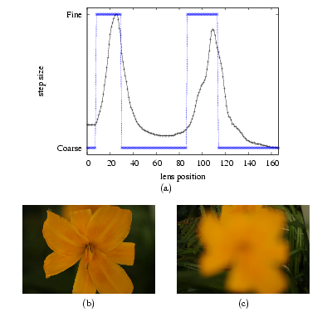

**Figure 3.11 (**a) Focus measures of images at each of the 167 lens positions (Canon 50 mm lens) for an example scene using the squared gradient focus measure (b) flower in focus (c) fern and grasses in focus [72]

As seen on the figure 3.11 (a), the two blue vertical bars identify the peaks in the focus measure. It corresponds to the image in (b) where the flower is in focus and (c) where the fern is in focus. This process makes use of an effective focus measure called the squared gradient.

$ϕ\left(p\right)= \sum_{x=0}^{M-1}{\sum_{y=0}^{N-2}{{\left(f\left(x,y+1\right)-f\left(x,y\right)\right)}^{2}}}$ (3.7)

Let $f\left(x,y\right)$ to be the luminance or grayscale at pixel $\left(x,y\right)$ in an image of size M × N pixels. Kehtarnavaz and Oh used the squared gradient by holding the focus measure constant. It was assumed that the region of interest is the entire image, but it can either specify the ROI by moving a rectangle over the desired part of the image when the camera is in the live preview mode or it can also have the camera automatically determine the object or region.

**Image Normalization**

There are several different ways to alter an image to improve contrast, but in this study, the researchers will take the minimum and maximum range of the image and scale it to the appropriate full bit range. The idea is to linear stretch all the values to fit them into the interval [0, max value]. In our case, we will be using an 8-bit RGB image. We must convert this RGB image into grayscale color space before doing normalization. In this 8-bit image, we have a total of 256 shades of grey. The images that we will be working on will have an intensity value of 0 and 255 assigned to each pixel. In a case where the captured image has poor contrast, and after histogram analysis, we realize that, for ALL of the pixels in the source image, the intensity values are on a sub-interval, [a,b], such that $a>0$ and $b<255$. (An example would be that the smallest intensity value is 17, and the largest is 40. That would imply that $a=17$ and $b=40$)

We want to scale and shift all the intensity values in our source image so that we can recreate the original image with all the intensity values re-assigned to an appropriate value on [0,255]. One very simple approach to this is the following “single pixel operation” (ie: each pixel in the output image is a function of a single pixel in the source/input image. In this case, we calculate some statistics from the source image and perform a linear shifting/scaling operation on the pixels in the source image to generate the pixels in the output image):

* Define the upper and lower limits for intensity values in the final output image ( ${out}_{max}$ and ${out}_{min}$; we are assuming that ${out}_{min}=0$, as we want the output of the histogram to be in the interval [0, ${out}_{max}$]
* Determine the upper and lower limits for intensity values in the source image, either by a simple search algorithm or histogram analysis ( ${in}_{max}$ and ${in}_{min}$)
* “Shift” all the intensity values by subtracting the value ${in}_{min}$ from each of them
* “Scale” all the intensity values by multiplying them by $\frac{{out}_{max}}{{in}_{max}-{in}_{min}}$

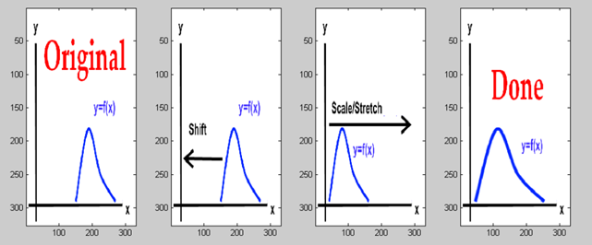

**Figure 3.12** Stretch/Scale Operation for Contrast Adjustment

This particular type of contrast adjustment can also be referred to as image normalization, because it normalizes the intensity values of the source image over the entire available data range (ie: [0,255]). The figure above shows the overview of what is happening to the histogram in the contrast adjustment method discussed above.

Another approach would be Histogram Equalization where it is defined as a technique for adjusting image intensities to enhance contrast. An image histogram is a graphic representation of the frequency counts of all allowable pixel intensities. Since the human eye is sensitive to contrast rather than absolute pixel intensities, we would perceive less information from an image with poor intensity distributions than from the same image with better intensity distributions. Images with skewed distributions can be helped with histogram equalization. Let us consider the image below:

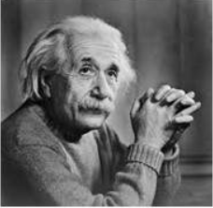

**Figure 3.13** Sample Image

The corresponding histogram of the image in Figure 3.13 is shown below:

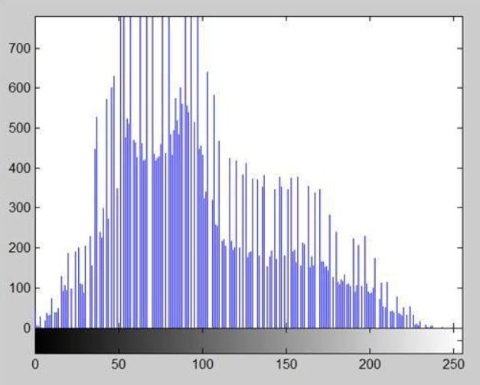

**Figure 3.14** Histogram of the sample image

Now, we will perform Histogram Equalization. Written below are the steps for Histogram Equalization:

* First, the researchers must calculate the PMF (Probability Mass Function),
* Next is the calculation of CDF (Cumulative Distributive Function)
* Then in this step the researchers will multiply the CDF value with (Gray levels (minus) 1).
* Considering the researchers have a 3 bpp image. The number of levels the researchers have are 8. Then, 1 subtracted to 8 is 7. So, multiply CDF by 7.
* Now in the last step, in which the researchers have to map the new gray level values into number of pixels. Assume the old gray levels values has these number of pixels.
* Now the researchers will map these new values on histogram. Next, they will apply this technique to the original image. After applying, the researchers will get the following image and its following histogram and compared it to the original image.

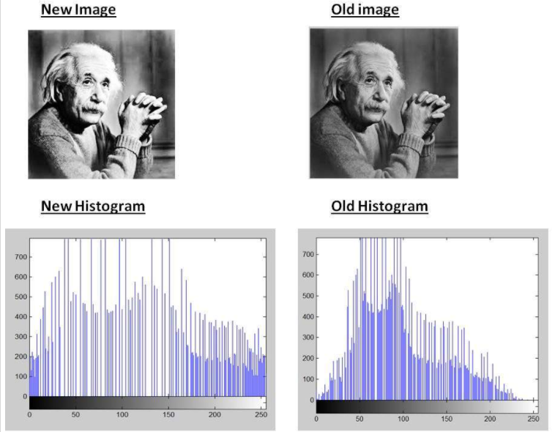

**Figure 3.15** Comparison of Old and New Image and Histogram

As you can clearly see from the images that the new image contrast has been enhanced and its histogram has also been equalized. There is also one important thing to be note here that during histogram equalization the overall shape of the histogram changes, whereas in histogram stretching the overall shape of histogram remains same.

**Edge Detection Process**

The Canny Edge Detector or the optimal detector is an algorithm that can detect all the edges in an image. This method will be implemented by an OpenCV function ‘canny’. The purpose of this algorithm is to satisfy the following: A low error rate to obtain a good detection of only the existent edges; A good localization where the distance between the edge pixels detected and real edge pixels must be minimized; A minimal response where wherein only one detector response per edge. These are the following process of canny edge detection:

1. Filter out the noise with the use of Gaussian filter. Example of a Gaussian kernel with a size = 5

$K= \frac{1}{159}\left[\begin{matrix}2 & 4 & 5 & 4 & 2 \\ 4 & 9 & 12 & 9 & 4 \\ 5 & 12 & 15 & 12 & 5 \\ 4 & 9 & 12 & 9 & 4 \\ 2 & 4 & 5 & 4 & 2\end{matrix}\right]$ (3.8)

1. Find the intensity gradient by,
2. Applying a pair of convolution mask in x and y directions

$G_{x}= \left[\begin{matrix}-1 & 0 & +1 \\ -2 & 0 & +2 \\ -1 & 0 & +1\end{matrix}\right]$ (3.9)

$G_{y}= \left[\begin{matrix}-1 & -2 & -1 \\ 0 & 0 & 0 \\ +1 & +2 & +1\end{matrix}\right]$ (3.10)

1. Finding the gradient strength and directions (Direction is rounded to one of four possible angles generally 0, 45, 90 or 135)

$G= \sqrt{G_{x}^{2}+G_{y}^{2}}$ (3.11)

$θ= \tan^{-1}\left(\frac{G_{y}}{G_{x}}\right)$ (3.12)

1. Apply non-maximum suppression to remove pixels that are not considered to be part of an edge. Only thon lines will exist.
2. Final step is hysteresis. Canny detection uses upper and lower thresholds,
3. If pixel gradient is higher than the upper threshold, the pixel is accepted as edge.
4. On the other hand, if the pixel gradient value is below the lower threshold, it will be rejected.
5. If the pixel gradient is between the thresholds, it will be accepted if it connects to a pixel that is above the upper threshold.

Note: Canny recommends an upper: lower ratio that is between 2:1 and 3:1

Applying the canny edge detection algorithm, an example below will be shown

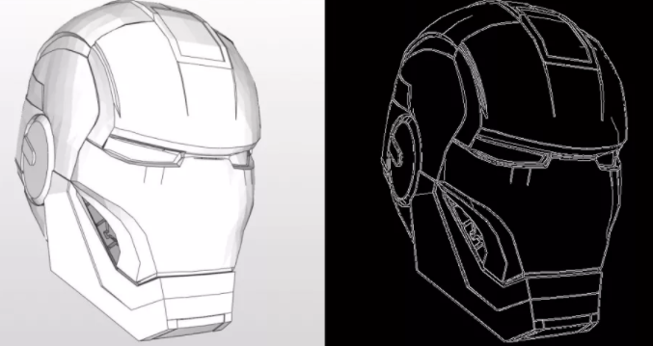

**Figure 3.16** Canny edge detection in OpenCV [73]

Based from the output of the canny edge detector operator in figure 3.16, it has a low error rate providing a great accuracy. The edges in the image were marked only once, for that reason, noise does not result in false edges.

**Localized Region Based Active Contour (Snake Method)**

Generally, snakes serve to extract an object of interest, which in our case is the pig, from the background using the gradient information fixed in the image. The internal energy contained in snake curve and is responsible for changing the shape of the curve corresponding to the shape of the desired object. To calculate this energy will be used a formula as follows:

$F\left(C\right)= μ.length\left(C\right)+v. area\left(inside C\right)$ (3.13)

The variable area (inside C) is used when there is a changes process of curves which only moving inside. In the implementation, the value ν = 0 is used because we desire that the curve can move out, so there is no need to use v.area(inside C). This energy is affected by the mu (μ) variable which regulates the elasticity of the curve shape which in the classical active contour also known as variable alpha (α). The researchers can do ‘hierarchical’ contours in OpenCV. What that means is, any contour (c1) enclosed inside another contour (c2) is treated as a "child" of c2. And contours can be nested to more than one level (So the structure is like a tree). OpenCV returns the tree as a flat array though; with each tuple containing the index to the parent contour. Next, we remove any contour that doesn't take up at least 5% of the image in area. This reduces the rest of the noise. Below is a sample of what the output will be.

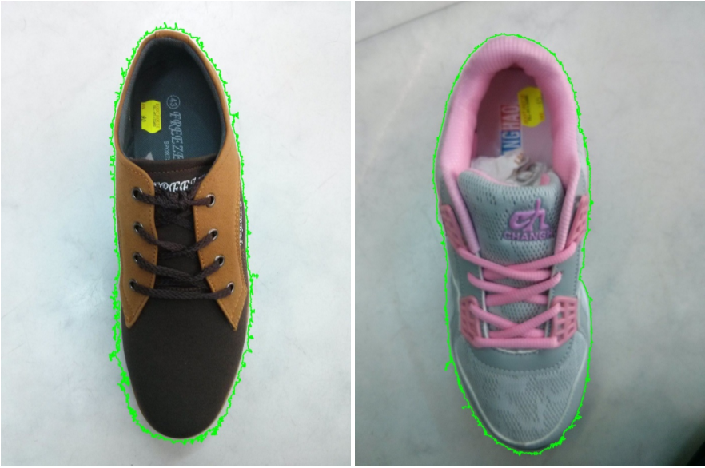

**Figure 3.17** Hierarchical Contour

As seen in figure 3.17, The algorithm could detect and outline the object of interest in the image. Here we see the final state of the “snake”, which is the green outline. This are composed of points which models or shapes the object of interest depending on its hierarchy. These points will only stop moving once they have detected the object of interest in the image. As seen, the outline is not smooth. This can be smoothened. If the image is resized down from ~700x900 to ~250x300 then the contours are going to be smoother and even noise reduces a lot. One way of smoothing this is to use an algorithm called "Savitzky-Golay filter". For Savitzky-Golay smoothing, one has to first install scipy and scipy.signal. The output of the said filter is shown below:

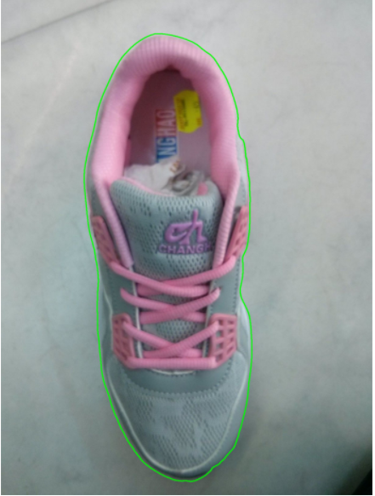

**Figure 3.18** Smoothened Contour

As seen in the image above, the contour has already been smoothened due to the application of a filter. This will lead us to the next step in our image processing. Finally, one can remove the background by creating a mask to fill the contours. This will result to a binary image which then will be used for feature extraction.

Another approach would be the greedy snake algorithm. For each point/pixel in the neighborhood of a snake control point v(si) the three energy terms are calculated. Then the algorithm sums the energy terms to get the combined energy.y. Once the combined energy has been calculated for each of the points in the neighborhood, the algorithm makes a greedy choice and moves the snake control point to the position that has the minimum combined energy. So, the name of the algorithm is derived from its behavior. Once all the control points along the snake have been moved to a new position the curvature is calculated a second time. This time however the curvature is only calculated once for each control point along the snake and not for all the points in the neighborhood. Written below is a pseudocode for greedy snake algorithm:

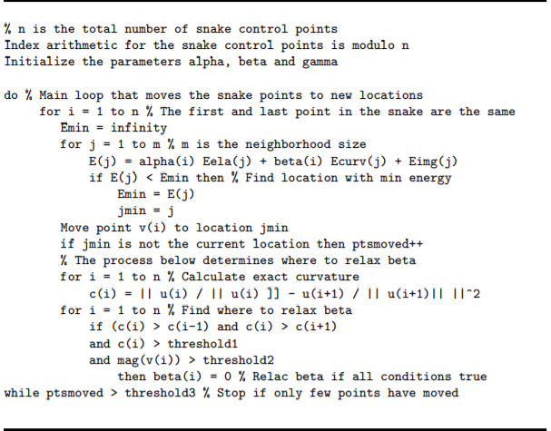

**Figure 3.19** Pseudocode for greedy snake algorithm [74]



**Figure 3.20** Initial State of the snake [74]

As seen in the figure above, there are 100 snake points equally spaced, organized in a circular manner. After running the code, the snake will start to move and will eventually yield an output of:

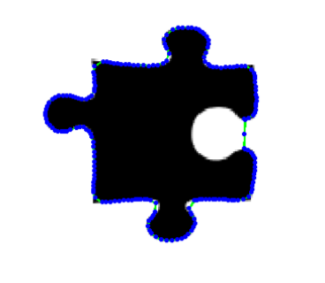

**Figure 3.21** Final state of snake when using resampling [74]

It is seen in the image above that the snake has stopped moving when it successfully outlined the image. This finals state will occur after several iterations. The final step in the iteration of the greedy snake algorithm consists of checking whether the number of points moved in the iteration is below the threshold. This is used as a stopping criterion as the snake is presumed to have reached minimum energy when most of the control points have stopped moving.

**Filtering**

After the segmentation process on the image of the pig, there may be some pixels not detected and some of the background pixels to be incorrectly detected. The filtering process that will be implemented for this study is the image opening, this is the process where erosion and dilation processes will occur respectively. This removes any background objects that were erroneously segmented, while preserving the image of the pig, meaning it smooths out the image without changing its size [75].

The erosion of an image strips away a layer of pixels from the boundaries of foreground regions, denoted by the equation [3]:

$g=f⊖s$ (3.14)

where $g$ is the resulting image, $f$ is the original image, and $s$ is the structuring element. The symbol $⊖$ indicates the erosion.

For dilation, it adds a layer of pixels to the boundaries of foreground regions, denoted by:

$g=f⊕s$ (3.15)

where $⊕$ indicates dilation.

Morphological opening works by taking the structuring element and sliding it around inside each foreground region without changing the orientation and size. All of the pixels that can be covered by the structuring element will be preserved. While, all foreground pixels that cannot be reached by the structuring element without parts of it moving out of the foreground region will be removed. The effect of an opening on a binary image using a 3×3 square structuring element is shown in the figure below.

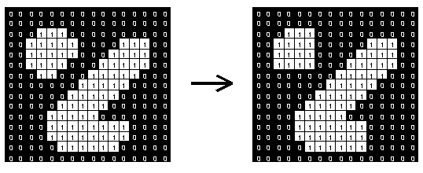

**Figure 3.22** Morphological opening using 3x3 square structuring element

Using 3x3 structuring element is very common to use. From the figure above, the effect is rather subtle since the structuring element is quite in compact and it fits into the foreground boundaries quite well even before the opening operation. Below is an example of image opening where it tends to preserve particular intensity patterns while attenuating others.

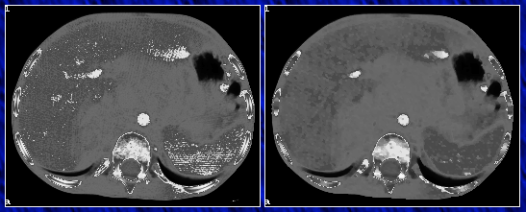

**Figure 3.23** Original image (left), Opened image (right) [76]

Figure 3.23 Shows the generalization to greyscale image. The greyscale opening is achieved by eroding the image with the structuring element first. Then, dilating the resulting image by the structuring element. It can be seen on the opened image that the process darkens small bright areas. It can entirely remove very small bright spots like noise spikes.

**Feature Extraction**

Feature extraction describes the relevant shape information contained in a pattern so that the task of classifying the pattern is made easy by a formal procedure. Moreover, feature extraction is a special form of dimensionality reduction. It is essential to focus on the feature extraction phase as it has an observable impact on the efficiency of the recognition system. Its main goal is to obtain the most relevant information from the original data and represent the information in a lower dimensionality space. In feature extraction phase, each character is represented by a feature vector, which becomes its identity [77]. The features to be extracted in this paper are the dimensions as well as the area of the pig.

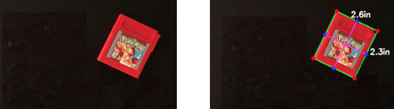After the implementing the preprocessing algorithms, features can now be extracted. To estimate the real size of an object in an image, onetime calibration process can be done. A reference object will be stored in the database wherein this reference object needs to have a known actual size [58]. The actual size of the reference object will be used in order to calculate for the pixels-per-metric ratio of the image which will relate the dimensions of the object in the captured image to its real size estimation [64].



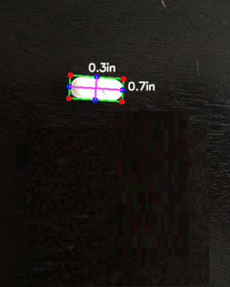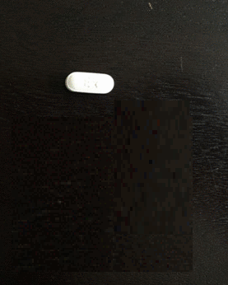

**Figure 3.24** Input and Output of Measuring the Dimensions of an Object Using OpenCV [64]

A Python driver script can be implemented to measure the dimensions of the object. However, before implying this the image should first be loaded and converted to gray scale and the preprocessing methods should first be applied. The output will show the resulting dimensions that will later be used in the calculation process [64]. As for the obtaining the area, according to Kollis et al., [12] the area of the object in pixels is trivially defined to be the sum of the binary pixel values over the whole image. A command in OpenCV can be used to be able to obtain the area of the object in an image.

In order to ensure that the accuracy of this extraction process is roughly 100%, two approaches should be taken into account: First, the angle between the camera and the object should be 90 degrees in order to prevent the image from getting distorted; Second, the extrinsic as well as the intrinsic parameters should be calibrated because without determining this parameter, the photos taken will be prone to radial and tangential lens distortion. Moreover, performing this calibration is significant since this will lead to better object size approximation [64].

**Step-by-step process of pre-processing technique [2]**

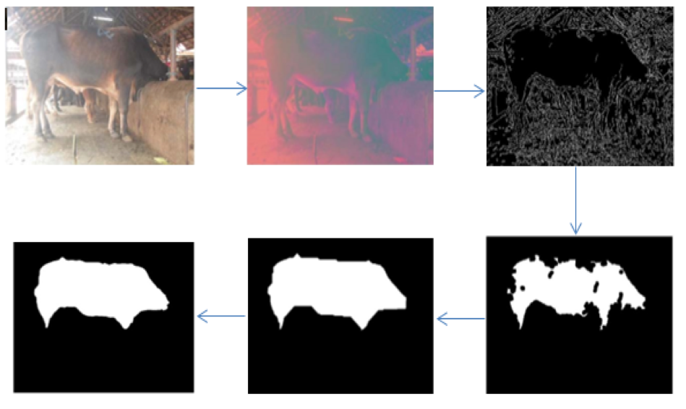

The purpose of the pre-process is to prepare the image before acquiring the features considered in calculating the weight of the pig. Included in the pre-processing are: detection of the pig, image segmentation and filtering. The steps of the pre-processing are written below:

1. To start, the camera will capture an image of the pig
2. Image will be formatted in .jpeg format and will be converted from RGB color space to either YCbCr or L*a*b* or HSV colors space.
3. Next step is the edge detection technique to outline the pig image so that the pig will become the image detail so that the pig will be separated from the background.
4. Then we fill up holes in the binary image. These are the pixels that cannot be reached by the filling in the background from the edge of the image.
5. Next, we perform morphological closing on the binary image. Closing is defined as dilation followed by erosion
6. We separate the background that is still incorporated using Localized Region Based Active Contour. This image will be used for feature extraction process.

The sample output of the system that will be showed in the LCD screen with the use of a proposed GUI is shown below:

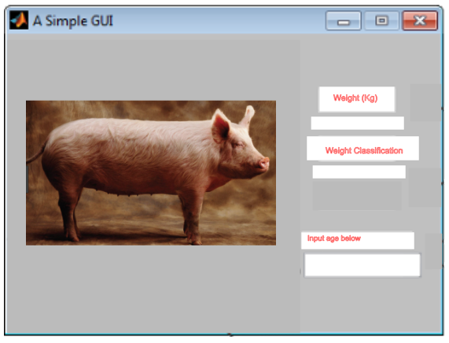

**Figure 3.25** Proposed GUI

As seen in the image above, the user will be required to input the age of the pig using the provided tab where the age of the pig will be inputted. The captured image of the device will be seen in the interface as well. Lastly, the estimated weight by the proposed image processing technique and the weight classification will be displayed as well.

**Statistical Analysis**

The researchers will be conducting a T-test another piggery: Piggery 2 (Uncontrolled). The actual and estimated weight in each piggery will be compared. A P-value will be calculated for each test. This will help the researchers verify if the proposed algorithm is indeed effective.

**PIGGERY 2: Testing**

**Table 3.7** Comparison of Actual and Estimated Weight in Piggery 2

|  |  |  |  |  |
| --- | --- | --- | --- | --- |
| Sample No. | Estimated Weight (kg) | Actual Weight (kg) | | % error |
| 1 |  |  |  | |
| 2 |  |  |  | |
| 3 |  |  |  | |
| 4 |  |  |  | |
| . |  |  |  | |
| . |  |  |  | |
| . |  |  |  | |
| 10 |  |  |  | |

In table 3.7, we are testing the effectiveness of the proposed algorithm by estimating pigs from a different piggery but with the same number of samples. First, we take a picture of a random pig and estimate its weight. Then we determine the actual weight of the same pig by manual measurements. After this, we can verify if our algorithm is indeed effective. The dependent variable in this statistical analysis is the *weight of the pigs* while the independent variable is the *method of weighing the pigs.*

Listed below are the steps in conducting the statistical analysis for both groups:

**Step 1:** Identify the hypothesis

$H_{0}:$ There is no significant difference between the actual weight and estimated weight

$H_{1}:$ There is significant difference between the actual weight and estimated weight

$$μ_{0}=actual weight$$

$$μ_{1}=estimated weight$$

**Step 2:** Specify α

The researchers will specify a significance level of $α=0.05$

**Step 3:** Compute for the test statistic:

**Table 3.8** Statistical Values of Original Piggery and Piggery 2

|  |  |  |  |  |  |  |  |  |
| --- | --- | --- | --- | --- | --- | --- | --- | --- |
| Variable | Mean | Std. Deviation | N | Diff. | Std. Dv. Diff. | t | df | P-value |
| Actual weight  Estimated weight |  |  |  |  |  |  |  |  |
|  |  |  |  |  |  |  |  |  |

Table 3.8 will be filled up by using an app called “Statistica”. This tool will help the researchers compute for the statistical values needed in their research.

**Step 4:** After getting the P-value, the researchers will identify the rejection rule:

**Rejection Rule:**

If $α>P-value$, reject $H_{o}$;

If $α<P-value$, do not reject $H_{o}$.

**Step 5:** Make a decision

Reject $H_{0}$ or do not reject $H_{0}$.

**Step 6:** Form a conclusion

The purpose of this thesis is to prove that our null hypothesis is true. This means that the calculated P-value must be greater than the significance level in both tests; having a greater P-value compared to the significance level means that there is no significant difference between the estimated weight and the actual weight of the pigs in both tests or it simply means that the values of estimated and actual weights are indeed close to each other.

The Formula below is used in obtaining the t-test values.

$t=\frac{\left({\overline{X}}_{1}-{\overline{X}}_{2}\right)-\left(μ_{1}-μ_{2}\right)}{\sqrt{\frac{S_{1}^{2}}{n_{1}}+\frac{S_{1}^{2}}{n_{2}}}}$ (3.16)

**References**

[1] Yang, Y., & Teng, G. (2008). ‘Estimating Pig Weight from 2D Images’. Retrieved from

https://link.springer.com/chapter/10.1007/978-0-387-77253-0_100

[2] Pradana, Z.H., Hidayat, B., Darana, S. (2016). ‘Beef Cattle Weight Determined By Using Digital Image Processing’. DOI: 10.1109/ICCEREC.2016.7814955

[3] Dramdahl, M. (2014). ‘Morphological Operations Applied to Digital Art Restoration’. Volume 1, Issue 2

[4] Kaur S., Singh, I. (2016). ‘Comparison Between Edge Detection Techniques’. Retrieved from http://ieeexplore.ieee.org/document/7100279/

[5] Kumbakhar, S.C., Tionas, E.G., Sipiläinen, T. (2009). ‘Joint Estimation of Technology Choice and Technical Efficiency: An Application to Organic and Conventional Dairy Farming’. Journal of Productivity Analysis, 31, 151-161. Retrieved from: https://link.springer.com/article/10.1007/s11123-008-0081-y

[6] Rahman, S. (2007). ‘Adoption of improved technologies by the pig farmers of Aizawl district of Mizoram, India’. Livestock Research for Rural Development, 19. Retrieved from: http://www.lrrd.org/lrrd19/1/rahm19005.htm

[7] Andersen, I.L., Navdal, E., Bakken, M., BØE, K.E. (2004). ‘Aggression and Group Size in Domesticated Pigs, Sus scrofa: ‘when the winner takes it all and the loser is standing small’. Animal Behavior, 68, 965–975. DOI:10.1016/j.anbehav.2003.12.016

[8] Farmer’s Handbook on Pig Production, 1st ed., Food and Agriculture Organization of the United Nations., Nepal, NP, 2009. Retrieved from http://www.fao.org/ag/againfo/

themes/documents/pigs/handbook%20on%20pig%20production_english%20layout-vietanm-draft.pdf

[9] Carr, J. ‘Garth Pig Stockmanship Standards’ Retrieved from http://www.thepigsite.com/stockstds/17/growth-rate/

[10] Dangphonthong, D., Pinate, W. ‘Analysis of Weight Egg Using Image Processing’. Retrieved from www.worldresearchlibrary.org/up_proc/pdf/165-145439307455-57.pdf

[11] Javadikia, P., Dehrouyeh, M.H., Naderloo, L., Rabbani, H., Lorestani, A.N. (2011). ‘Measuring the Weight of Egg with Image Processing and ANFIS Model’. DOI: <https://doi.org/10.1007/978-3-642-27172-4_50>

[12] Kollis, K., Phang, C., Banhazi, T., Searle, S. (2007). ‘Weight Estimation Using Image Analysis and Statistical Modelling: A preliminary Study’. DOI: 10.13031/2013.22332

[13] Brandl, N., Jørgensen, E. (1996). ‘Determination of live weight of pigs from dimensions measured using image analysis’. Computers and Electronics in Agriculture. 15, 57-72. http://doi.org.https.sci-hub.mn/10.1016/0168-1699(96)00003-8

[14] Kashiha, M., Bahr, C., Ott, S., Moons, C.P.H., Niewold, T.A., Odberg, F.O., Berckmans, D. (2014). ‘Automatic Weight Estimation of Individual Pigs Using Image Analysis’. Computers and Electronics in Agriculture. 107: 38-44.

[15] Zhu, Q., Ren, J., Barclay,D., McCormack, S., Thomson, W. (2015). ‘Automatic Animal Detection From Kinect Sensed Images for Livestock Monitoring and Assessment’. DOI: 10.1109/CIT/IUCC/DASC/PICOM.2015.172

[16] Schofield, C.P. (1990). ‘Evaluation of Image Analysis as a Means of Estimating the Weight of Pigs’. J. Agric. Engng Res. 47:287-296.

[17] Clark, A. (2015). ‘Calculating the Weight of a Pig through Facial Geometry using 2-Dimensional Image Processing’. Texas Tech University.

[18] Goel, R., Kumar, V., Srivastava, S., Sinha, A.K. (2017). ‘A Review of Feature Extraction Techniques for Image Analysis’. Retrieved from http://ieeexplore.ieee.org/document/6783417/

[19] Tasdemir, S., Urkmez,A., Inal,S. (2011). ‘Determination of Body Measurements on the Holstein Cows Using Digital Image Analysis and Estimation of Live Weight with Regression Analysis’. Computers and Electronics in Agriculture. 76: 180-197.

[20] Storbeck, F., Daan, B. (1990). ‘Weight Estimation of Flatfish by Means of Structured Light and Image Analysis’. Fisheries Research. 11: 99-108.

[21] Klatt, G. and Glende, P (1975). ‘TierkorpermaBe bei Schweinen als Grundlage fur

tiergerechte Stand- und Buchtenkonstruktionen’. Tierzucht, 29: 420-422.

[22] Petherick, J.C. (1983). ‘A Note on Allometric Relationships in Large White X Landrace Pigs’. Anim. Prod., 36: 497-500.

[23] Scan Beam A/S (1990). PO. 118, Norregade lo,9500 Hadsund, Denmark

[24] Wold, S. (1974). ‘Spline Function in Data Analysis’. Technometrics, 16(l): 1-1 1.

[25] SAS Technical Report P-229 (1992). SASSTAT Software, Release 6.07, SAS Institute Inc., Cary, N.C., USA.

[26] Kashiha, M.A. et al. (2012). ‘Automatic Identification of Marked Pigs in a Pen Using Image Pattern Recognition’. Computer Electronics Agriculture.

[27] Schofield, C.P., Marchant, J.A., White, R.P., Brandl, N., Wilson, M. (1999). ‘Monitoring Pig Growth Using a Prototype Imaging System’. J. Agric. Eng. Res. 72, 205–210

[28] Schinkel, A.P., Einstein, M.E., Jungst, S., Booher, C., Newman, S. (2009). ‘Evaluation of Different Mixed Model Nonlinear Functions to Describe the Body Weight Growth of Pigs of Different Sire and Dam Lines’. Prof. Anim. Sci. 25, 307–324

[29] Kongroso, J. (2014). ‘Estimation of Pig Weight using a Microsoft Kinect Prototype Imaging System’. Computers and Electronics in Agriculture. 109: 32-35.

[30] N, Otsu. ‘A threshold selection method from gray level histograms’. IEEE Trans. Syst. Man. Cybern, vol. SMC-9, pp. 62-66, 1979.

[31] P. L. Rosin, ‘Measuri rectangularity’. Machine Vision and Application, vol. 11, pp. 191-196, 1999.

[32] Shrivakshan, G., Chandrasekar, C. (2012). ‘A Comparison of various Edge Detection

Techniques used in Image Processing’

[33] A. Blake and M. Isard. ‘Active Contours’. Cambridge, MA: Springer, 1998.

[34] N. Paragios, Y. Chen, and O. Faugeras. ‘Handbook of Mathematical Models in Computer Vision’. New York: Springer, 2005.

[35] J.-M. Morel and S. Solimini. ‘Variational Methods for Image Segmentation’. Boston, MA: Brikhauser, 1994

[36] S. Osher and R. Tsai (2003). ‘Level set methods and their applications in image science’ Commun. Math. Sci., vol. 1, no. 4, pp. 1–20

[37] S. Kichenassamy, A. Kumar, P. Olver, A. Tannenbaum, and A. Y. Jr. ‘Conformal curvature flows: From phase transitions to active vision’. Arch. Ration. Mech. Anal., vol. 134, no. 3, pp. 275–301, Sep. 1996

[38] V. Caselles, R. Kimmel, and G. Sapiro, ‘Geodesic active contours’. Int. J. Comput. Vis., vol. 22, no. 1, pp. 61–79, Feb. 1997.

[39] Lankton, S. (2008). ‘Localizing Region-Based Active Contours’. IEEE TRANSACTIONS ON IMAGE PROCESSING, VOL. 17, NO. 11: 2029-2039

[40] S. C. Zhu, A. Yuille. ‘Region competition: Unifying snakes, region growing, and bayes/mdl for multiband image segmentation’. IEEE Trans. Pattern Anal. Mach. Intell., vol. 18, no. 9, pp. 884–900, Sep. 1996.

[41] T. Chan and L. Vese, ‘Active contours without edges’. IEEE Trans. Image Process., vol. 10, no. 2, pp. 266–277, Feb. 2001.

[42] J. A. Yezzi, A. Tsai, and A. Willsky, ‘A fully global approach to image segmentation via coupled curve evolution equations’. J. Vis. Comm. Image Rep., vol. 13, no. 1, pp. 195–216, Mar. 2002.

[43] M. Rousson, C. Lenglet, and R. Deriche, ‘Level set and region based propagation for diffusion tensor MRI segmentation’ in Workshop Math. Meth. Biomed Imag. Anal., 2004, pp. 123–134

[44] O. Michailovich, Y. Rathi, and A. Tannenbaum, ‘Image segmentation using active contours driven by the bhattacharyya gradient flow’. IEEE Trans. Image Process., vol. 15, no. 11, pp. 2787–2801, Nov. 2007.

[45] N. Paragios and R. Deriche, ‘Geodesic active regions: A new framework to deal with frame partition problems in computer vision’. Int. J. Comput. Vis., vol. 46, no. 3, pp. 223–247, Feb. 2002.

[46] K. Sum and P. Cheung, ‘A novel active contour model using local and global statistics for vessel extraction’ in Proc. Eng. Medicine Bio. Soc., 2006, pp. 3126–3129.

[47] K. Sum and P. Cheung, ‘Vessel extraction under non-uniform illumination: A level set approach’. IEEE Trans. Biomed. Eng., vol. 55, no. 1, pp. 358–360, Jan. 2008

[48] T. Brox and D. Cremers, ‘On the statistical interpretation of the piecewise smooth mumford-shah functional’ in Proc. Scale Space Var. Met. Comp. Vis., 2007, vol. 4485, pp. 203–213.

[49] D. Mumford and J. Shah, ‘Optimal approximations by piecewise smooth functions and associated variational problems’. Comm. Pure Appl. Math, vol. 42, pp. 577–685, 1989.

[50] D. Mumford, ‘A bayesian rationale for energy functionals’ in Geometry Driven Diffusion in Computer Vision, B. Romeny, Ed. Dordrecht, The Netherlands: Kluwer, 1994, pp. 141–153.

[51] A. Bhattacharyya, ‘On a measure of divergence between two statistical populations dened by their probability distributions’. Bull. Calcutta Math. Soc., vol. 35, pp. 99–110, 1943.

[52] Shih,L. ‘Autofocus survey: A comparison of algorithms’. Cypress Semiconductor, 10 Wilson Rd. Floor 3, Cambridge, MA 02138

[53] Zhang, X., Liu, Z., Jiang M., Chang M. (2014). ‘Fast and Accurate Auto-Focusing Algorithm Based on the Combination of Depth from Focus and Improved Depth from Defocus’. DOI:10.1364/OE.22.031237

[54] Mir, H., Xu, P., Beek, P. ‘An extensive empirical evaluation of focus measures for digital photography’. University of Waterloo, Waterloo, Canada

[55] ‘Contrast detection autofocus vs. Phase detection autofocus’. Retrieved from https://www.jmpeltier.com/2017/12/08/difference-phase-detection-contrast-detection autofocus/

[56] ‘Morphological Dilation and Erosion’. Retrieved from https://www.mathworks.com/

help/images/morphological-dilation-and-erosion.html

[57] ‘Morphological Filtering’. Retrieved from http://scikit-image.org/docs/dev/auto_exam

ples/xx_applications/plot_morphology.html

[58] Priya S., Chaithanya C., (2015). ‘Object Weight Estimation From 2D Images’. Retrieved from http://www.arpnjournals.com/jeas/research_papers/rp_2015/jeas_0915_

2602.pdf

[59] Helmenstine, A. (2016). ‘Sources of Error In Science Experiments’. Retrieved from https://sciencenotes.org/error-in-science/

[60] Coe, T. R., Halkes, M., Houghton, K., Jefferson, D. (1999). ‘The accuracy of visual estimation of weight and height in pre-operative supine patients’. DOI: 10.1046/j.1365-2044.1999.00838.x

[61] Velardo, C., Dugelay, J. L. (2010). ‘Weight Estimation from Visual Body Appearance’ DOI: 10.1109/BTAS.2010.5634540

[62] Koehn, P. (2004). ‘Statistical Significance Tests for Machine Translation Evaluation’. *Proceedings of the 2004 Conference on Empirical Methods in Natural Language Processing.*

[63] CRAMER, D., & HOWITT, D. L. (2004). ‘The SAGE Dictionary of Statistics: A Practical Resource for Students in the Social Sciences’. SAGE Publications Ltd., London.

[64] Rosebrock, A. (2016). ‘Measuring Size of Objects in an Image with OpenCV’. https://www.pyimagesearch.com/2016/03/28/measuring-size-of-objects-in-an-image-withopencv/

[65] Burke, J., Nuthall, P., McKinnon, A., (2004). ‘An Analysis of the Feasibility of Using Image Processing to Estimate the Live Weight of Sheep’. Retrieved from https://researcharchive.lincoln.ac.nz/handle/10182/98

[66] Wesolowski, M. (2014). ‘Using MATLAB to Measure the Diameter of an Object within an Image’. Retrieved from http://www.egr.msu.edu/classes/ece480/capstone/fall14/

group05/docs/app_matt.pdf

[67] Kainz, O., Jakab, F., Horecny, M., Cymbalak, D. (2015). ‘Estimating the Object Size from Static 2D Image’. Retrieved from http://ieeexplore.ieee.org/document/7344423/

[68] ‘What is the Raspberry Pi 3? Everything you need to know about the tiny, low-cost computer’. Retrieved from http://www.zdnet.com/article/what-is-the-raspberry-pi-3-every

thing-you-need-to-know-about-the-tiny-low-cost-computer/.

[69] ‘Raspberry Pi Camera Board v2 - 8 Megapixels’. Retrieved from https://www.adafru

it.com/product/3099

[70] ‘Official Raspberry Pi 7" Touchscreen Display’. Retrieved from https://thepihut.com/

products/official-raspberry-pi-7-touchscreen-display

[71] Kogelman, L.J.A., Kadarmideen, H.N., Fredholm, M. (2013). ‘An F2 Pig Resource Population as a Model for Genetic Studies of Obesity and Obesity-Related Diseases in Humans’. DOI: 10.3389/fgene.2013.00029

[72] Mir, H., Xu, P., Beek, P. ‘An autofocus heuristic for digital cameras based on supervised machine learning’. University of Waterloo, Waterloo, Canada

[73] ‘Edge detection in OpenCV and Python – Detect edges in video and image’. Retrieved from https://shahsparx.me/edge-detection-opencv-python-video-image/

[74] Tiilikainen, N. P. (2007). ‘A Comparative Study of Active Contours’

[75] Digital Image Processing: Bernd Girod, © 2013 Stanford University – Morphological Image Processing 20. Retrieved from https://web.stanford.edu/class/ee368/Handouts

/Lectures/2014

_Spring/Combined_Slides/7-Morphological-Image-Processing-Combined.pdf

[76] ‘Morphological Operations: An Overview’. Retrieved from http://www.inf.uszeged.hu/

ssip/ 1996/morpho/morphology.html

[77] Kumar, G., Bhatia, P. (2014). ‘A Detailed Review of Feature Extraction in Image Processing Systems’ DOI: 10.1109/ACCT.2014.74

[78] Donna J. Williams, and Mubarak Shah. (1991). ‘A Fast Algorithm for Active Contours and Curvature Estimation’. Jurnal. Florida: Department of Computer Science, University of Florida, Orlando

[79] Hernsworth, PH., Barnett, J.L., and Hansen, C.(1981) ‘The Influence of Handling by Humans on the Behavior, Growth, and Corticosteroids in the Juvenile Female Pig.’ Hormones and Behavior 15:396-403

[80]Gonyou, HW, Hernsworth, PH., and Barnett, J.L.(1985). ‘Productivity and Behavior of Pigs Subjected to Different Handling Treatments During the Growth Period’ Paper presented at the Canadian Society of Animal Science, Charlottetown, Prince Edward Island, Canada (Abstract)

[81]Mertsching, H.J. and Kelley, KW.(1983). ‘Restraint Reduces Size of Thymus Gland and PHA Skin Swelling in Pigs’. J Anim. Sci., Supplement 1. 57.175-176 (Abstract)

[82]Ewbank, R.(1968). ‘The Behavior of Animals in Restraint.’ In: Abnormal Behavior in Animals. Fox,MW, ed., pp.159-178. W.B. Saunders Co., Philadelphia.

[83]Hernsworth, PH., Brand, A., and Willems, P.(1981).’ The Behavioral Response of Sows to the Presence of Human Beings and its Relation to Productivity.’ Livestock Prod. Sci. 8:67-74

[84]Seabrook, M.F. (1984). ‘The Psychological Interaction Between the Stockman and His Animals and Its Influence on the Performance of Pigs and Dairy Cows.’ Vet. Rec. 115(4):84-87

[85]Grandin, T. (1986). ‘Minimizing Stress in Pig Handling in the Research Lab.’ Lab Animal, Vol.15, No. 3